FAQ: Transition from PebblePad v3 to PebblePad v5

Swansea University 4th August 2017

FAQ: Transition from PebblePad v3 to PebblePad v5 1
Swansea University 4th August 2017 1
1) What will be new in PebblePad v5? 1
2) Where can I find help to get started with PebblePad v5? 6
3) What will happen to all my assets and resources in Pebblepad v3 after the upgrade to v5? 7
4) How do I add files and evidence to my Asset Store? 8
5) How will I share an asset or resource in PebblePad v5 10
6) How can I submit an asset/resource to an ATLAS workspace from PebblePad v5? 11
7) How will my current assets/resources look in PebblePad v5? 11
8) How can I create new assets and resources in PebblePad v5? 15
9) Will the ATLAS’ interface remain the same after the upgrade on August 4th 2017? 17
10) Does PebblePad v5 support new features? 17
11) Are there any features of PebblePad v3 which will not be supported in v5? 19

This guide was created by Mari Cruz García and is reproduced with the kind permission of the University of Edinburgh.

What will be new in PebblePad v5?

The main difference between PebblePad v3 and PebblePad v5, after the upgrade, is the interface for Pebble+. This is the portfolio element of PebblePad in which you can create and share different assets and resources. Please note that PebblePad consists of two element: Pebble+, the portfolio element, and ATLAS, the assessment area where you submit work.
The following screenshots show the differences in the interfaces of Pebble+ for the version 3 and version 5.
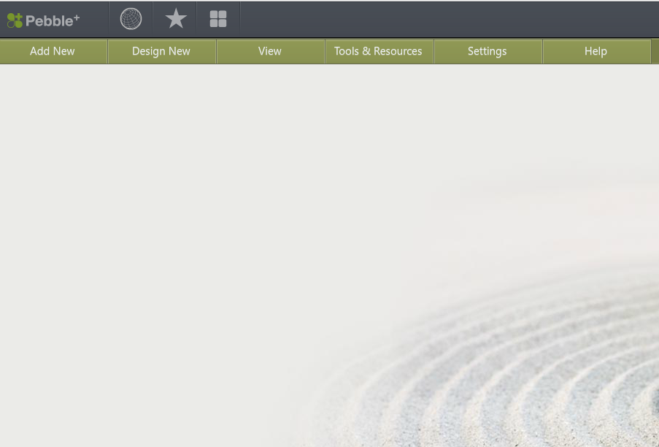
Template builder to generate different types of templates (e.g. workbook, feedback template)
Main menus to generate access and resources
Quick navigation links
Old interface in Pebble+ v3
New interface of PebblePad v5
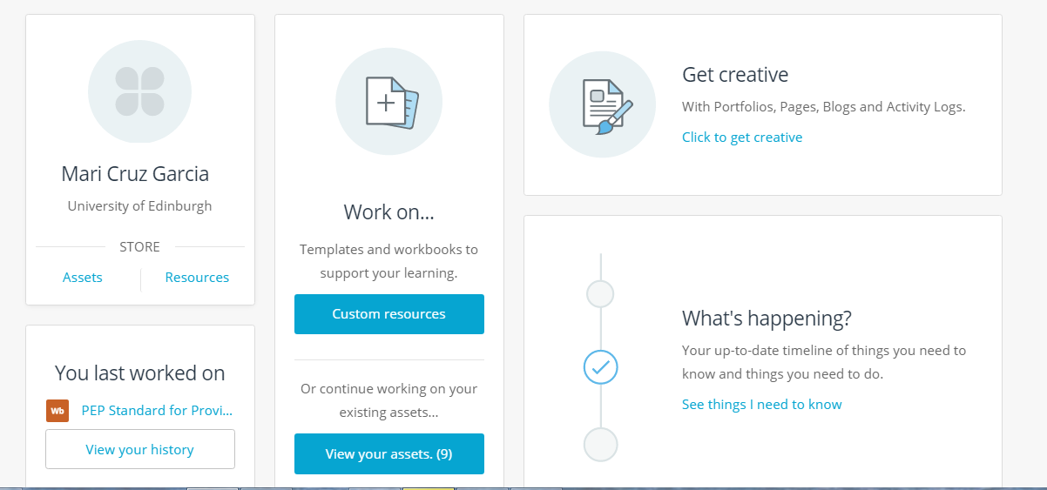

Pebblepad v5 has a more intuitive and user friendly interface in which it is easier to navigate. These are the main menus that you should know to find your way around the new interface:

- The Asset and Resource Stores:
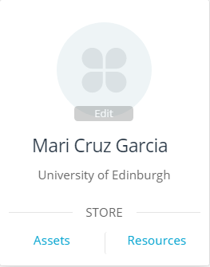

All the different search options available in PebblePad v3 will remain in V5. This also includes filtering assets and resources by ownership, tags and specific dates:
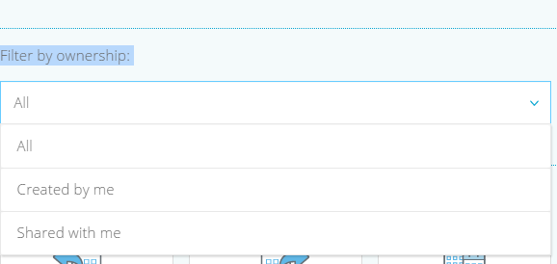

- The history of what you have been working on recently:
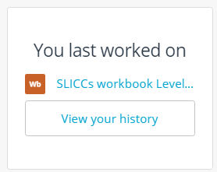

- How to create new assets/resources:
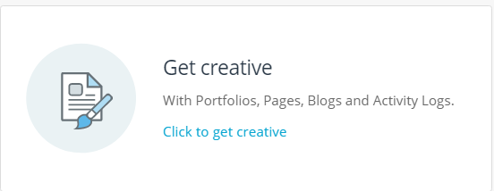
- How to customise the templates available at PebblePad:

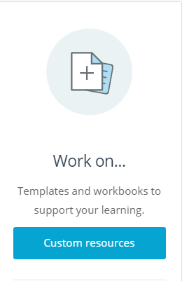

You may also find useful to have a look to the ‘What’s happening?’ menu, which displays the latest actions regarding your assets and resources

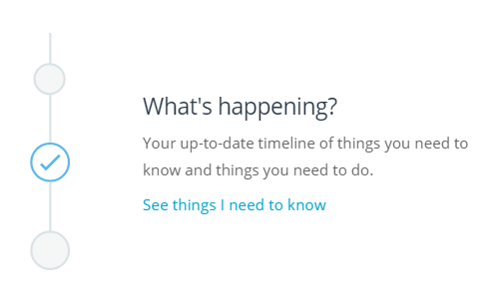
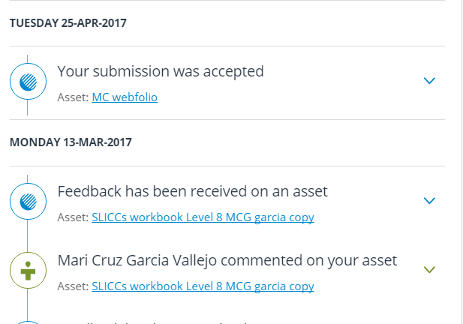

Where can I find help to get started with PebblePad v5?

- The “Learning centre”menu is located on the frontpage of Pebble+. The Learning Centre is the starting point to find your way around the new interface:

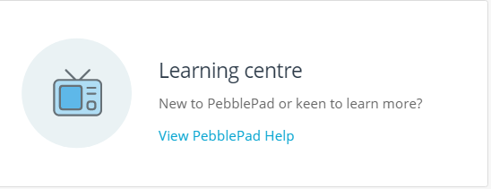

The Learning Centre contains useful guides and videos on how to get started with PebblePad. This includes a collection of videos on how to get started with PebblePad, how to organise and submit your work for assessment, how to share your work with other users and how to use the templates and workbook that PebblePad offers.

What will happen to all my assets and resources in Pebblepad v3 after the upgrade to v5?

All the assets and resources that you had stored in Pebble+ will be kept safe after the upgrade to PebblePad v5, albeit the interfaces of ‘Asset Store’ and the ‘Resource centre’ will look different:

This is how the Asset Store looks in Pebble+ v5:
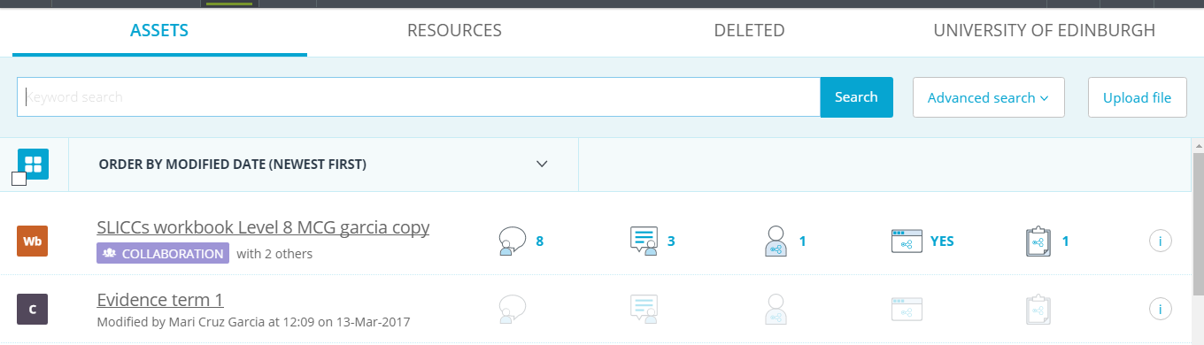

and this is the new interface for the Resource Centre:
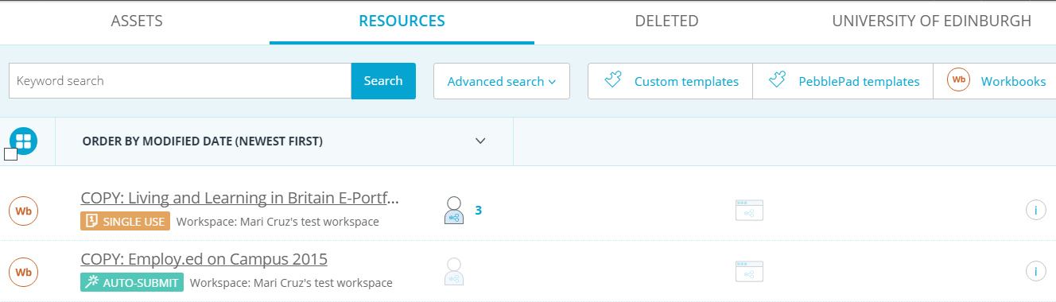

The new interfaces display the same information for each of the assets and resources that were imported from Pebble+ v3 but using more intuitive icons:

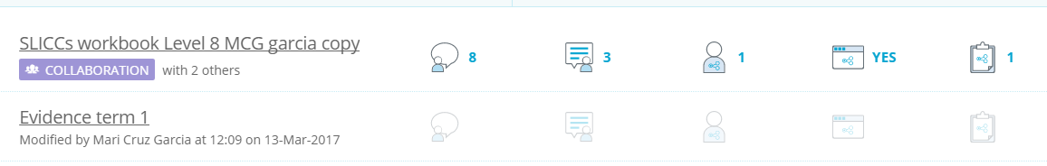

Some of the most important icons are:

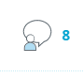 | Comments: When you share an asset with other users, it displays the comments on the assets
 | Feedback: It displays the feedback that an asset submitted to ATLAS has received
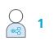 | Share: It displays the users with whom you are sharing the asset or resource
 | Wider share: It shows that you are sharing the asset/resource to external users in the Internet

How do I add files and evidence to my Asset Store?

Old method of uploading files in Pebble+ v 3
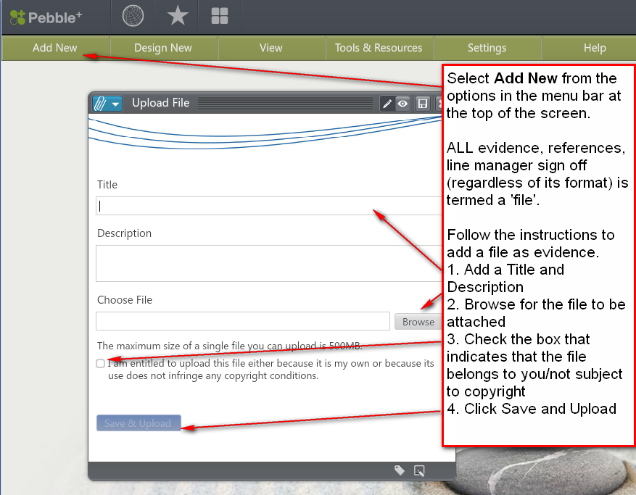

This has been replaced with this process in PebblePad v5.
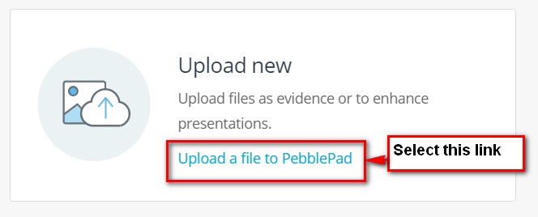

This screen appears, enabling you to add entire folders or individual files.

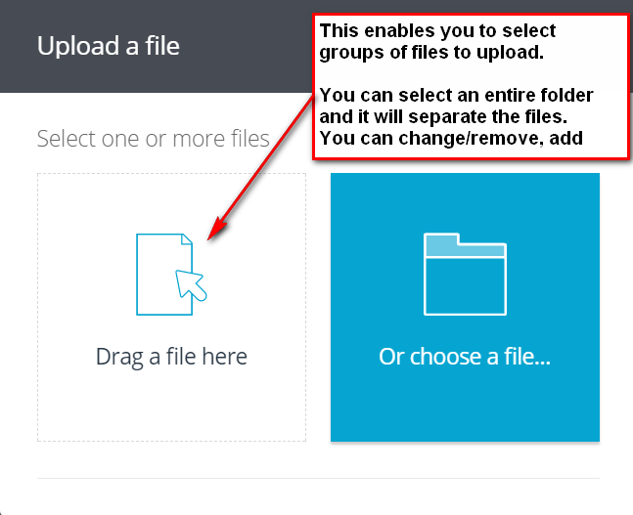

How will I share an asset or resource in PebblePad v5

The procedure for sharing an asset or resource is the same as that for PebblePad v3, just select the share icon and select what you want to do with the asset:
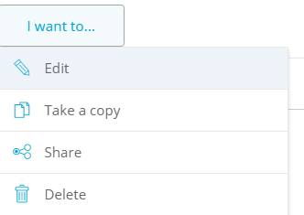

Alternatively, if somebody has shared a resource or asset with you, you can also select to take a copy provided the settings of the asset allow you to do so:

The ‘Share’ menu supports different ways of sharing: with other users, with the Internet or you can submit the asset for assessment:

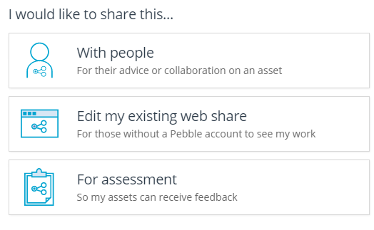

How can I submit an asset/resource to an ATLAS workspace from PebblePad v5?
Select that asset that you want to submit, click on the ‘Share’ icon and click on the menu ‘I want to’, then the option ‘Share’:

And select ‘Share for assessment’:

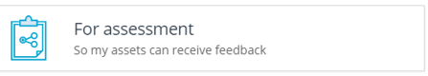

Finally, choose the workspace you want to submit the asset to:

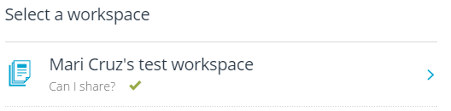

How will my current assets/resources look in PebblePad v5?

Most of your current assets and resources will remain the same in PebblePad v5. Please note that webfolios are called “portfolios” in PebblePad v5 so if you cannot find your webfolios, do not panic as they will appeared listed as “portfolios” in the Asset Store:

If you own workbooks, pages, portfolios (webfolios), blogs and, in general, any template that you want to share as a resource to a workspace, please check that the content of the asset is displayed correctly in the new interface of Pebble+. You may want to resize images, the length of some text fields, adding images as a banner, etc.

Workbooks and portfolios will experience some slight layout changes in PebblePad v5. See below examples of how your workbooks and portfolios would look like in PebblePad v5 compared to v3:

This how a workbook looks in PebblePad v3:
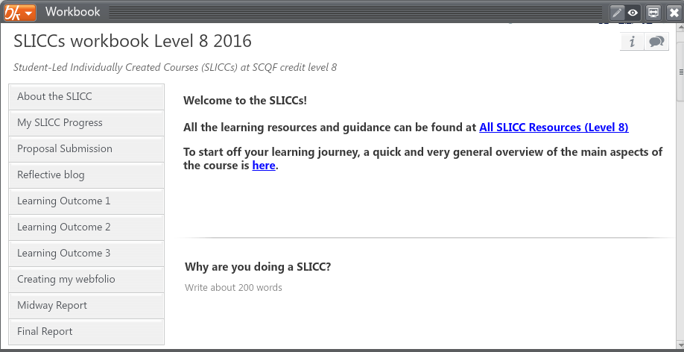

And this is how the same workbook looks in PebblePad v5:
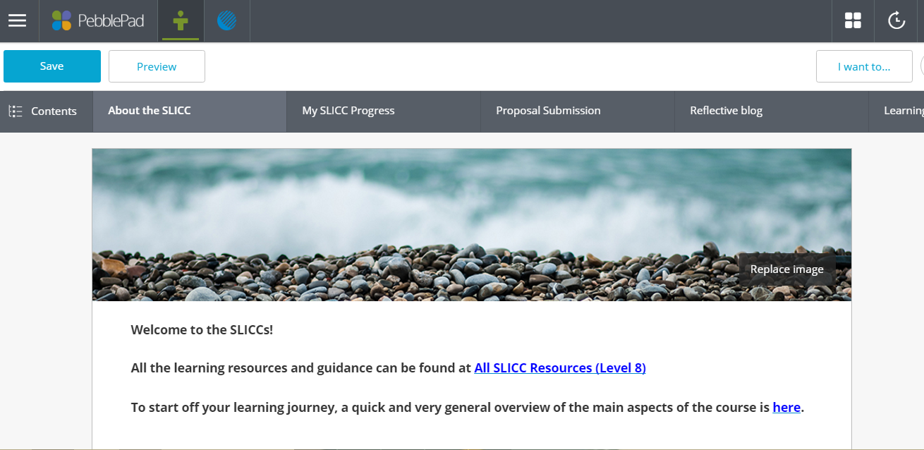
New navigation bar and banner image

This is how a webfolio looks in PebblePad v3:
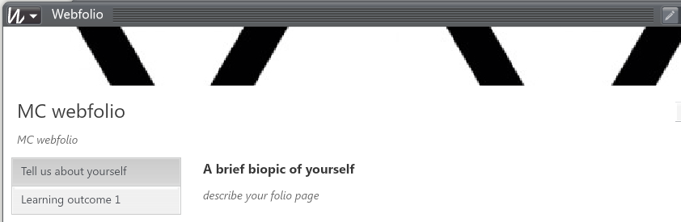

And this is how the webfolio (now called portfolio) will look in PebblePad v5:

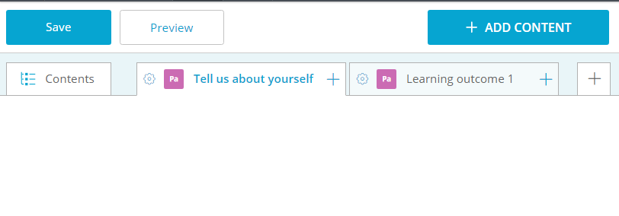
Contents are now displayed on a new horizontal bar

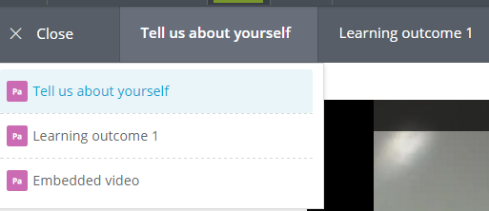
In version v5, both the workbook and the portfolio support a pop-out contents icon on the far left of the menu, displaying a vertical index to facilitate navigation in mobile devices

How can I create new assets and resources in PebblePad v5?

There are different ways of creating new assets and resources in the new interface of Pebble+ v5. This interface is more intuitive and you will be prompted to try the different menu options.

You can create a new asset from the frontpage of Pebble+ by clicking on the ‘Get creative’ menu and then selecting the asset that you want to create:

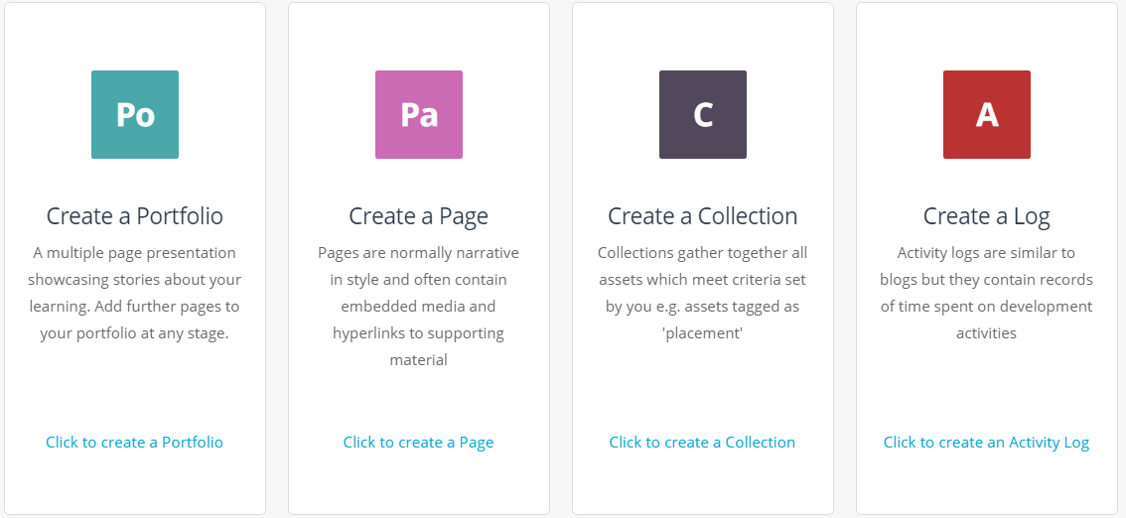

Or by clicking on the ‘Burger’ menu from any webpage of Pebble+:

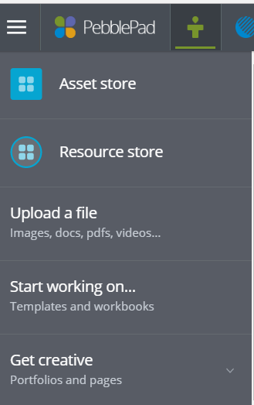

Will the ATLAS’ interface remain the same after the upgrade on August 4th 2017?

Yes, the interface of ATLAS will remain the same. The upgrade will only affect the interface of Pebble+. The only change that you will notice in ATLAS is the new layout of the feedback menu when accessing the feedback of an asset or resource that has been created in Pebble+ v5:

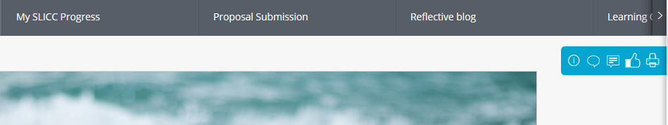

Tutors/markers will also see this new menu layout when providing feedback for students’ submissions:

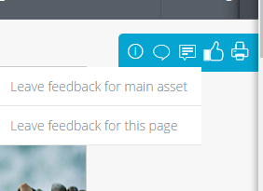

You will now be able to add page-level comments, feedback and grades in Workbooks.

Does PebblePad v5 support new features?

Yes, PebblePad v5 supports new features and new assets that were not supported in v3. You can try those new features after the upgrade on August 4th 2017.

Some of the new features that PebblePad v5 supports are:
- Embedding iframes (from Media Hopper, YouTube, Vimeo, Prezi, etc.) into pages:

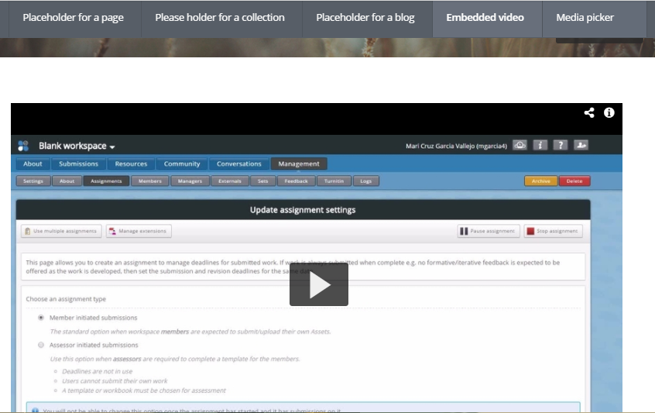

- Placeholder pages in workbooks .so that learners can add their own assets (pages, collections, blogs and activity logs) into a blank page in a workbook:

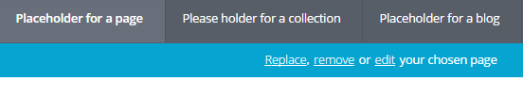

- Rubrics that can be added to workbook and feedback templates:
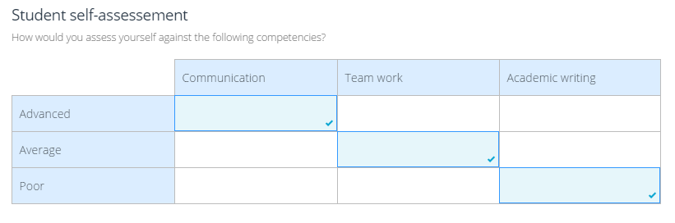

Are there any features of PebblePad v3 which will not be supported in v5?

Yes, there are some minor features of PebblePad v3 which will not be supported in V5.
Please be aware of those features to put alterative solutions in place:

- You will not be able to link different user accounts in PebblePad v5.
That means that if, for instance, you have a student account and a staff account in PebblePad, you will not be able to link your student account to your staff account, to transfer assets and resources between accounts after the upgrade on August 4th 2017.

Nevertheless, as explained in previous paragraphs, the assets and resources that you have for each of the accounts will not be affected.

- If you use the tab “Conversations” for your ATLAS workspace and you save the summary of a conversation to your Asset store, this summary will not be displayed in v5:

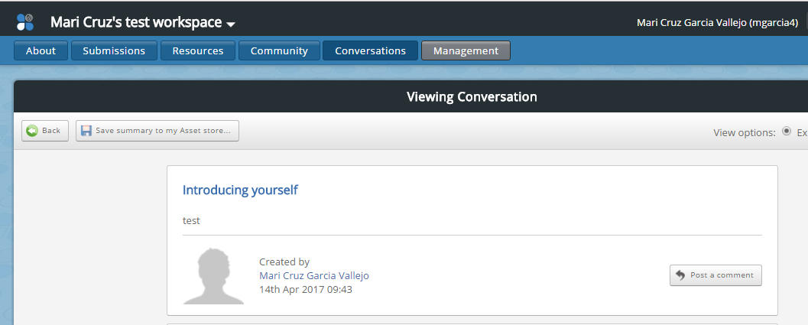

If you want to keep your Conversations’ summaries, please make sure that you download those summaries as printable pdfs:

