Converting PowerPoint Slides into a Clicker Presentation
- Using TurningPoint, you can easily transform a traditional PowerPoint slide into an interactive TurningPoint question slide.
- Open your PowerPoint question slide. The questions must be in the title field, and the answer choices in the bulleted textbox below.
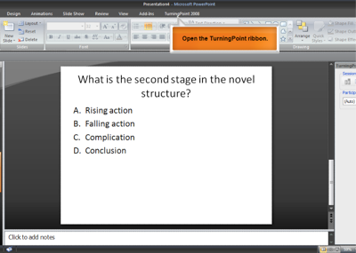
- Next, press the insert object button from the TurningPoint ribbon, and select Charts from the dropdown menu. Select your desired chart type.
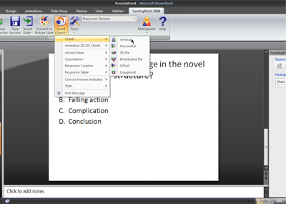
- The slide will be converted into a TurningPoint question slide, allowing you to set correct answers, and insert extra TurningPoint objects.
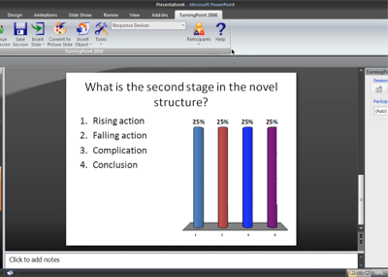
- For other training options, including how to set a correct answer for your question slides, please visit our tutorials and training pages on our website: TurningTechnologies (opens in a new window).

