1 - QUICK GUIDE TO EDITING AND MANAGING COURSE MENUS

When you click on a link to your module you will see a page like this where you can access and edit menu areas, the Control Panel and add course themes.
Not all course will look exactly like this as they may have been edited already and may have menu buttons rather than text but the controls are all the same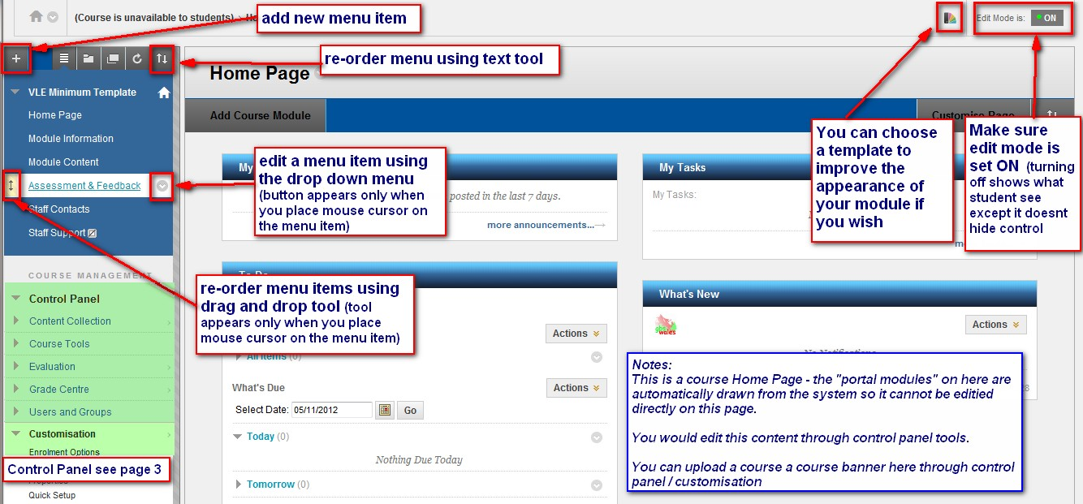

2 - QUICK GUIDE TO ADDING AND EDITING CONTENT

Pretty much all types of content can be added directly in any content area – you can edit any item by clicking in the items space so that the small edit button appears this will give you a context sensitive menu for what you can do with the item. In the Build Content area “Item” and “folder” are the best ones to use for pretty much any type of content.
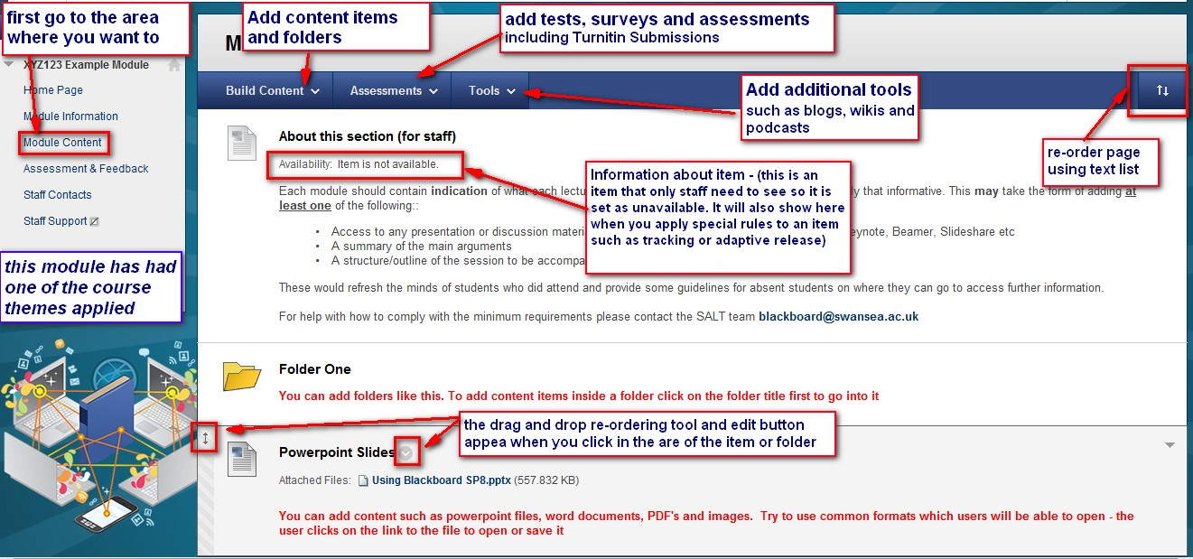

3 - QUICK GUIDE TO COURSE CONTROL PANEL

You will need to use the control panel for specific tool as most of the main content management tasks are accessed directly from the course menu pages. You will need to use it to access certain tools and services that instructors need – such as posting announcements, making calendar entries and checking submitted Turnitin assignments.
