Playing Gravity
Overview
Type the definition as the term falls down the screen. As you move up in levels from planet to planet, gravity will increase, making the terms fall faster and faster. Get a term wrong and the next time it comes back, it'll be a red asteroid. Get a red asteroid wrong and the game will be over. Compete with your friends to get the high score and show off your knowledge.

How it works
Click on Gravity on the set page
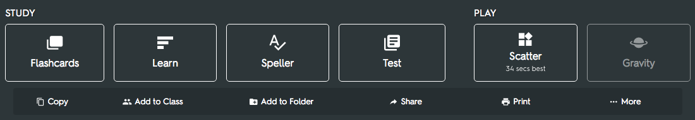
Select your game settings
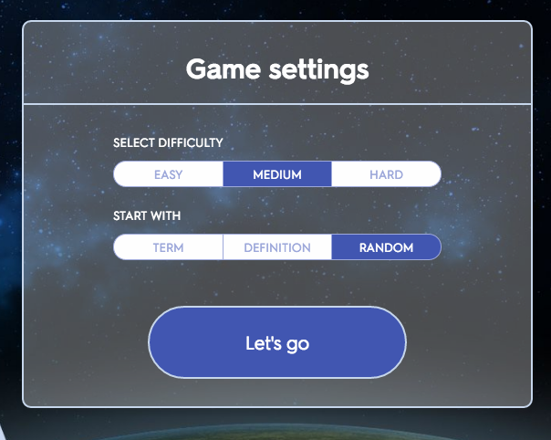
Choose from easy (always the same slow speed), medium (moving from slow to fast), or hard (starting fast). The faster you go, the higher points you'll get for each correct answer. And decide whether you want to see the term, definition, or either ("random") scrolling down the screen.
Type the answer quickly
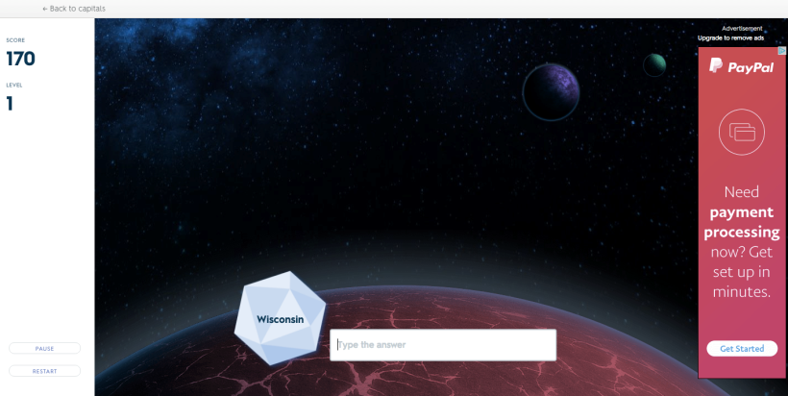
Terms will fall down the screen as asteroids, going faster as you move up in levels. Type the answer correctly before the term gets to the bottom of the screen to get points.
Copy the answer if you get it wrong
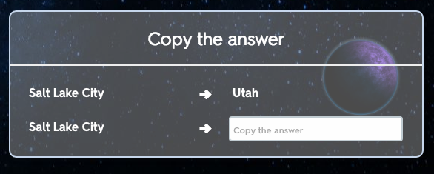
If you get an answer wrong and the asteroid goes off the screen, you'll need to copy the answer to move forward.
Watch out for red asteroids
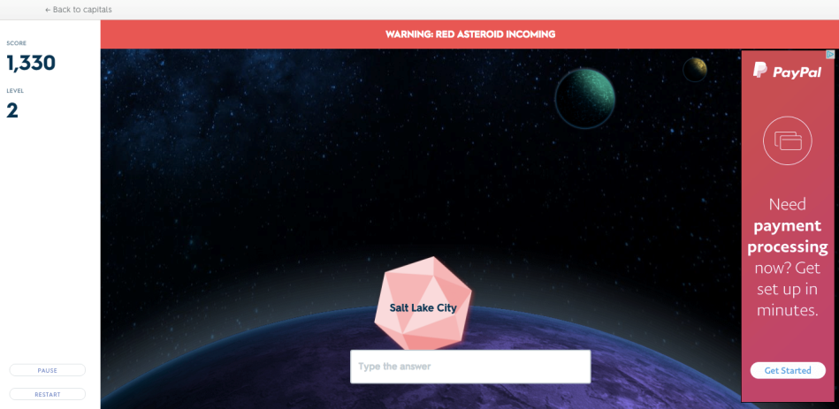
Words you get incorrect will come back more often as red asteroids. And when they do, you'll need to answer correctly or lose the game.
A new level every 7 terms
Every 7 terms, you'll move to a new planet and gravity will increase. This means the terms will fall faster.
Press esc to skip a word
If you don't know a term, press escape and you'll skip directly to the copy answer screen where you find see the correct answer.
High Scores
The top ten high scores are displayed in the "Scores tab of the main set page.
