Playing Scatter

Overview
Quizlet keeps learning lively with Scatter! Race against the clock to match terms and definitions and compete for the top score with your friends.
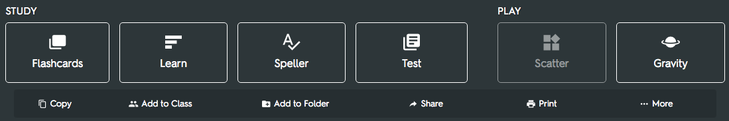

How it works
Quizlet scatters the back and front of the study sets on your screen.
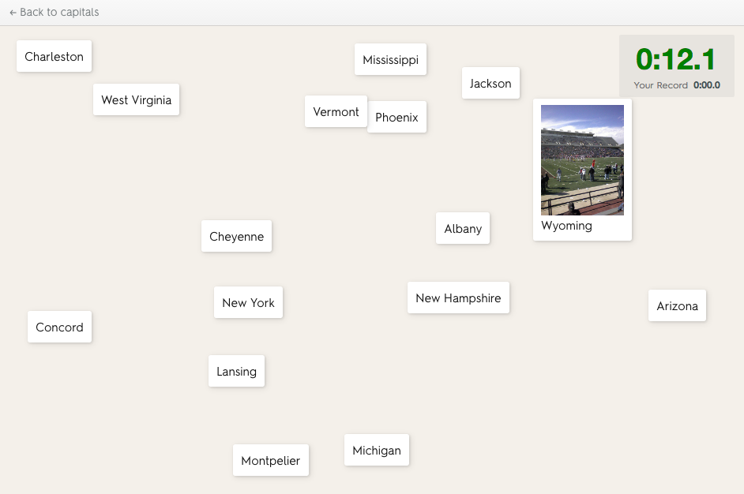
Match the terms and definitions by dragging and dropping them with your mouse.
Go as fast as you can!
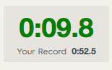

High Scores
Compete with friends to beat the record.
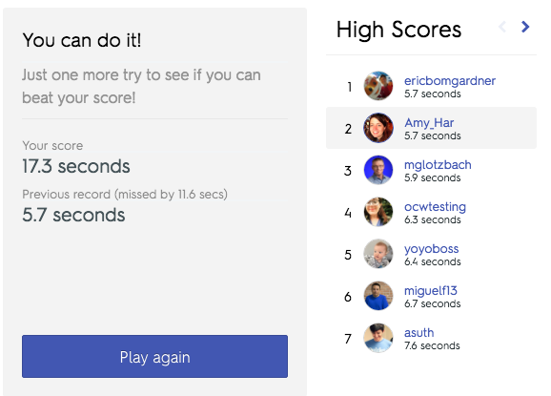
The top ten high scores are displayed on the "Scores" tab of the main set page.
