Using Flashcards
Flashcards mode allows you to study Quizlet sets as flashcards.
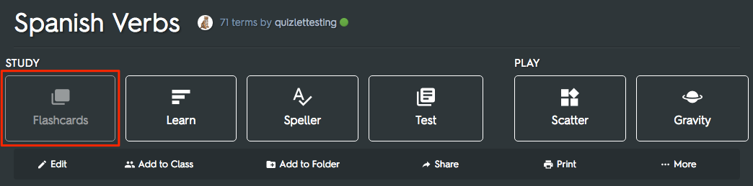
The arrow buttons allow you to flip between cards in the study set, and you can click the bottom right corner of a card to flip it and view the other side.You can also use the left and right arrow keys to move between cards, and the space bar to flip them.
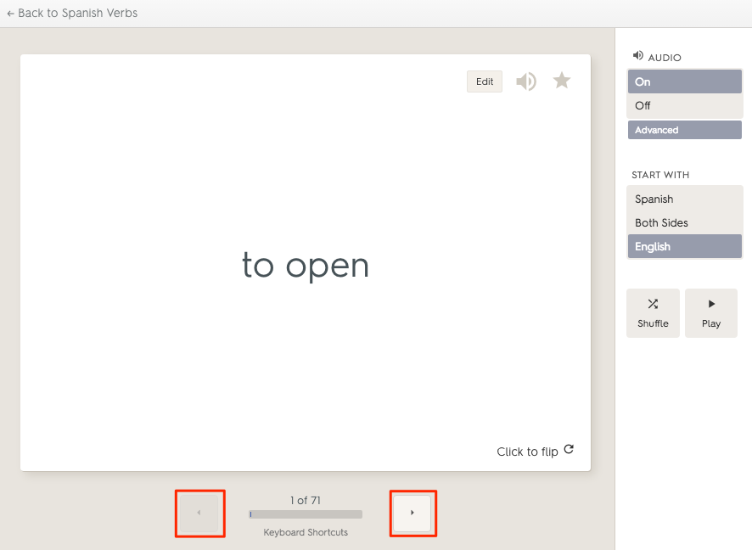

Custom settings
The default setting for Flashcards is to show the definition, then the term. If you want to see terms first, or see both sides, select Start with in the sidebar and select the option you'd like to use when studying.
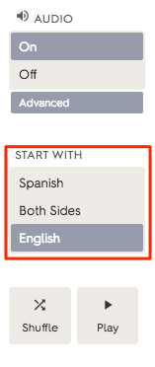
You can choose to enable or disable audio on any set that we support TTS audio for. If available, audio will play for terms and definitions as they're displayed.
The Advanced menu allows you to slow down the audio speed and lets you enable audio for only terms or definitions (or turn it off entirely).
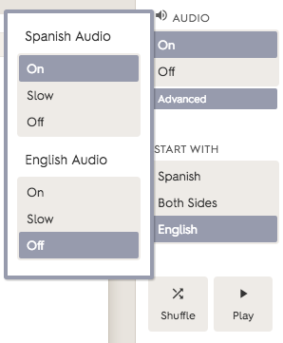
Shuffle will display your terms and definitions in a random order, and Play cycles through the flashcards automatically.
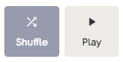
Combine audio with Play to hear your flashcards read out to you!

