Using Learn mode

Overview
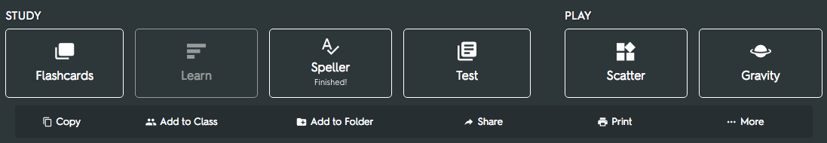
Learn Mode tests your knowledge of a subject after you've studied it a few times.
It keeps track of what you know and what you don't and retests you on your mistakes.

How it works
Learn prompts you with the back or the front of the flashcards you made.
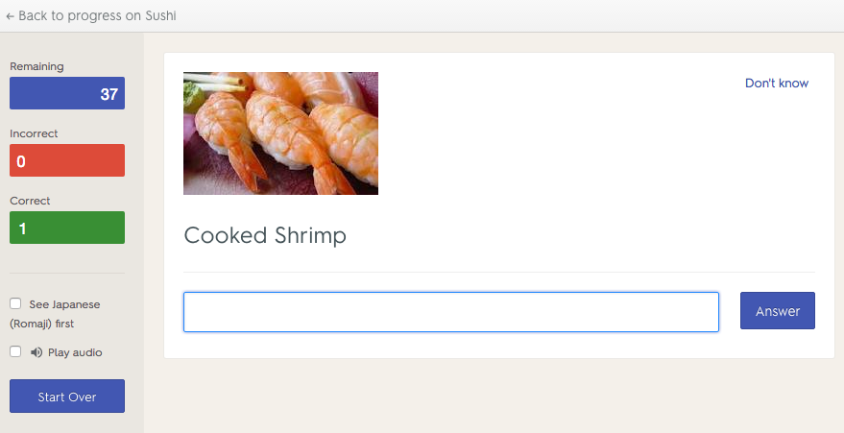
A correct answer is put in the "Correct" bucket. An incorrect answer is put in the "Incorrect" bucket. If you don't know the answer and select "Don't Know," Learn makes you retype the answer correctly to proceed.
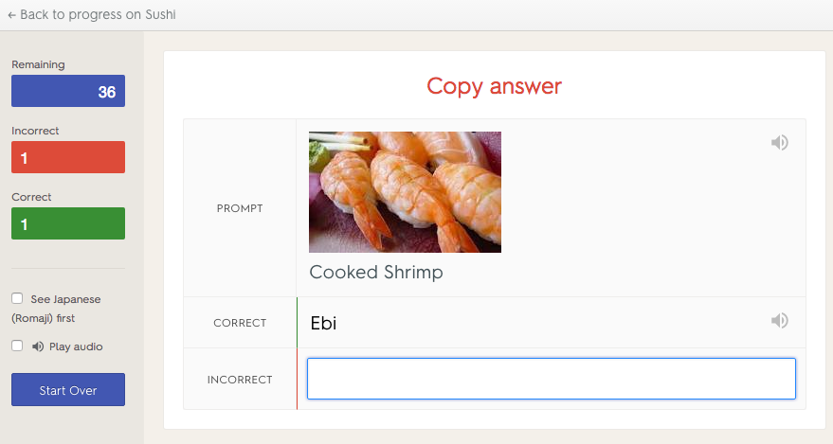
Quizlet tracks what you get right and wrong as you progress through a set. At the end of each round, Quizlet retests you on what you missed.
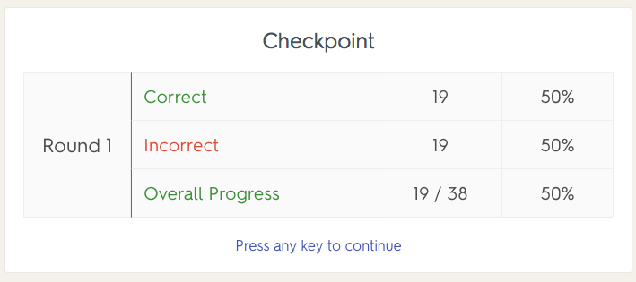
Answer every term/definition correctly twice in a row and Learn mode ends, showing you which words you missed or answered correctly in each round.
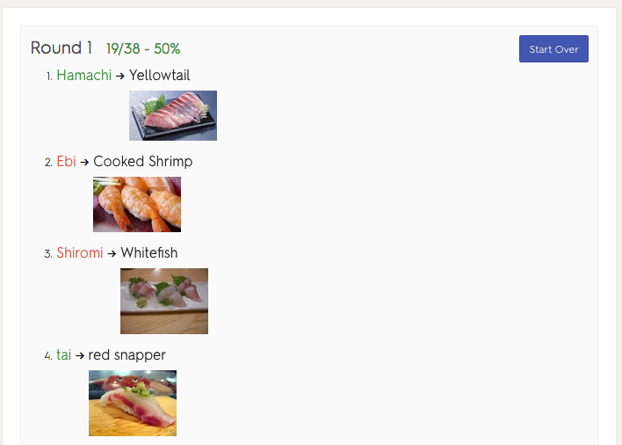

Retest missed answers
After completing Learn mode you can choose to star the terms you missed and study just them.
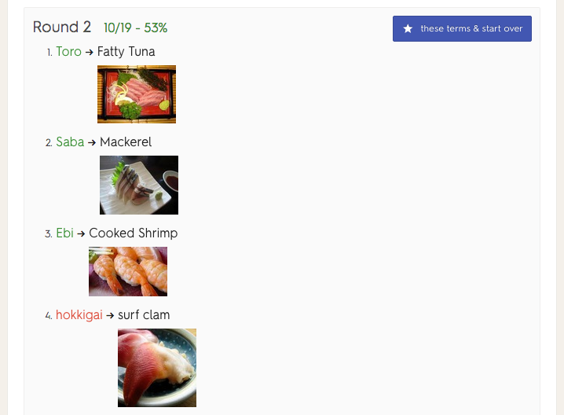

Customize Learn Mode
Quizlet can prompt you with either side of the card.
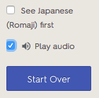
You can also turn on audio for Learn, by checking the "Speak Text" box. Click on the speaker icon to replay the audio.

Edit in Learn Mode
If you notice a mistake (or want to make a change) to your term or definition while in Learn Mode, it's easy to fix.
After you answer the question (or give up), click "Edit."
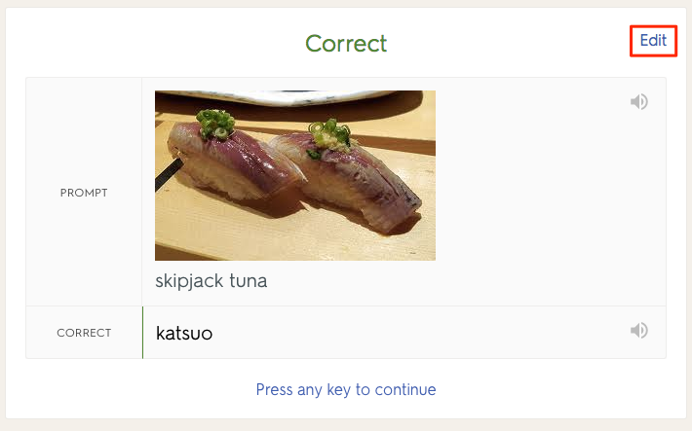
Then change whatever you'd like in the term or definition and click "Save."
