Using Speller
In Speller you type what you hear. This mode works best for foreign language vocabulary and pronunciation, spelling, and familiarizing yourself with terms you don't know very well.
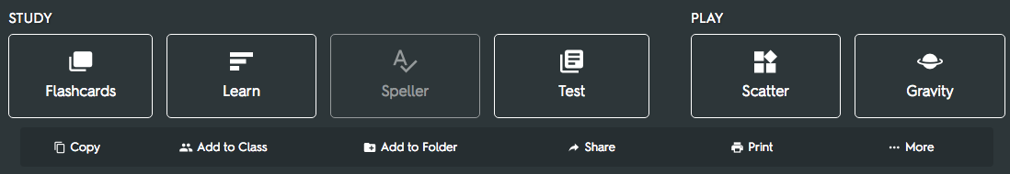
With audio in 18 languages, Speller works automatically with almost any flashcard set.

How it works
Listen to a term or definition and type in the correct response. Click on the "replay audio" button or click "esc" to repeat the term. In this case the answer is “sake.” If you type it in correctly you move on to the next question. If you make a mistake, Speller shows you which letters you missed so you can try again.
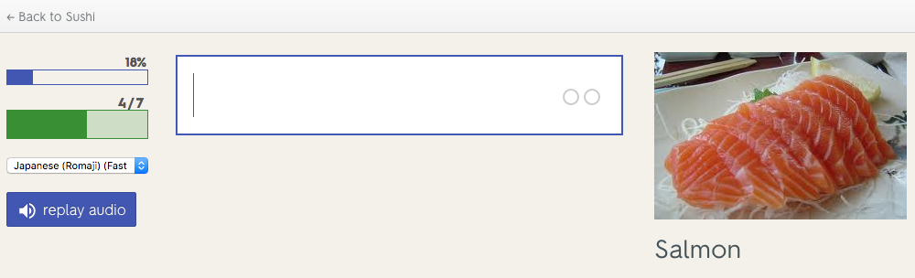
In this example, the term was not spelled correctly. “Saka” was entered rather than “sake.” Speller shows that the the first part of the word “sak” was spelled correctly and then highlights in green the proper letters to spell out the rest of the word. Speller then speaks the term again, “sake,” and spells out the correct spelling word letter by letter: “s”, “a”, “k”, “e”.
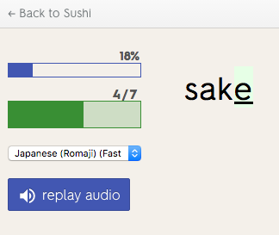
You must spell the word correctly to move on to the next term. Speller asks 7 terms per round, and in between rounds you see a Progress Checkpoint to see how you’re doing. You must answer each term correctly twice in a row for it to count as "Fully Learned."
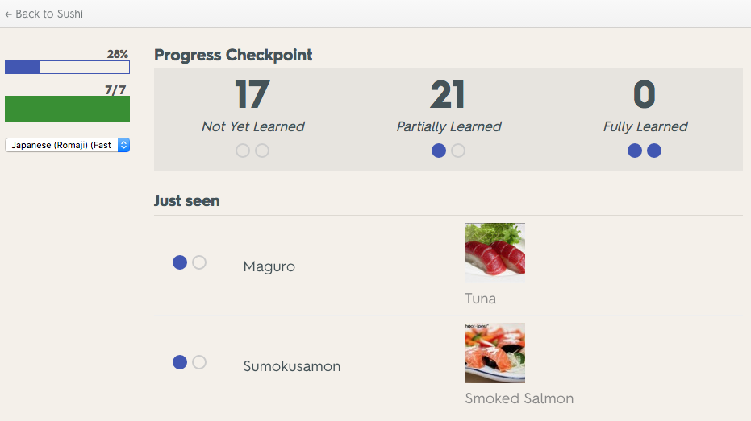
Speller is complete once you’ve "Fully Learned" each term. On the results page you can see the percentage of answers correct in each round and which words you missed. You can repeat Speller again or move onto other Quizlet study modes like Flashcards, Learn, Test, Scatter, or Space Race.
