Using Test mode

Overview
You can take customized practice tests on any study set or print it out and practice on paper.
Step 1: Click the Test button on the main set page:
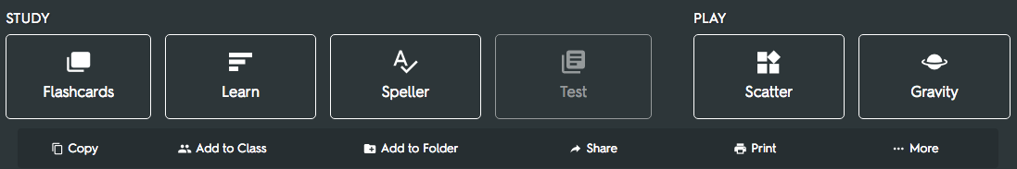
Step 2: Customize your Test
Quizlet will automatically generate a random test for you using the terms and definitions from your set of flashcards. On the righthand sidebar you can customize:
- Question Types (Written, Matching, Multiple Choice, or True/False)
- Prompt With (Term, Definition)
- Question Limit
Click "Create new test" to create your custom quiz.
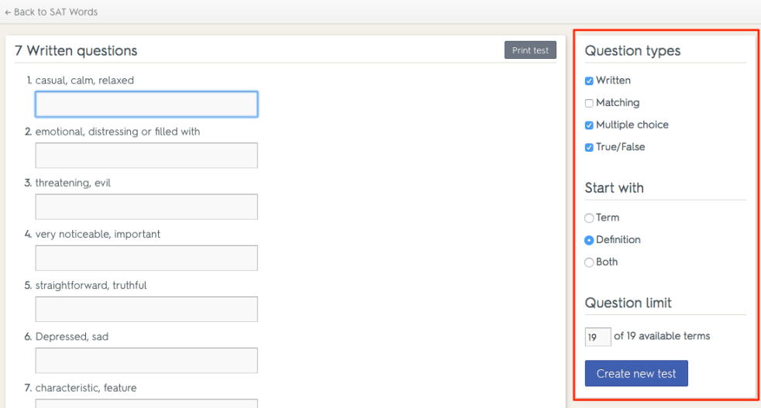
Step 3: Take the test
Enter in your answers and click "Check Answers" at the bottom of the page.
Step 4: Check your score
See how you did on your test! Your grade is in the upper righthand corner of the screen.
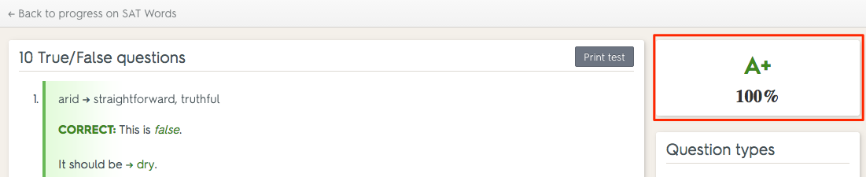
Step 5: Print/Share your test
Click "Print test" to print out your Test.
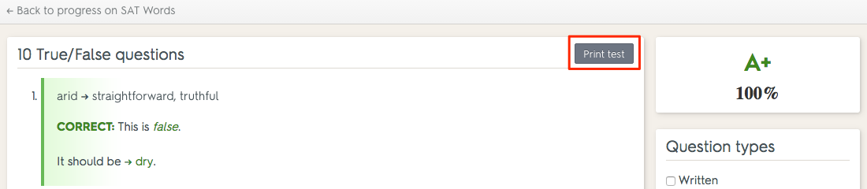
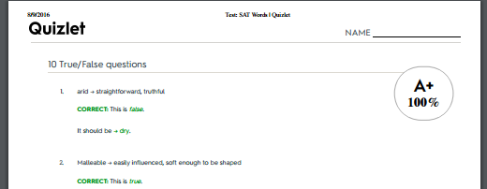
You can bring a printed copy to class, or save it as a PDF to email to your teacher.
Step 6: Repeat!
Click "Create new test" to randomly generate another test with new questions. Keep practicing until you get an A+.
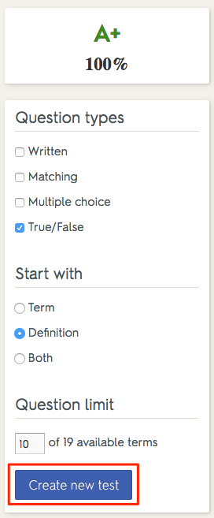

Quizzes for Class
You can also print out a blank test to distribute in class.

