Guide to making your lecture recording available via Blackboard

1. Access the module on Blackboard where you wish to make the lecture recording available
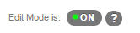
2. Navigate to the applicable Content Area. It is recommended that you create a content area specifically for the recordings (see the additional notes at the end of this document for further guidance)
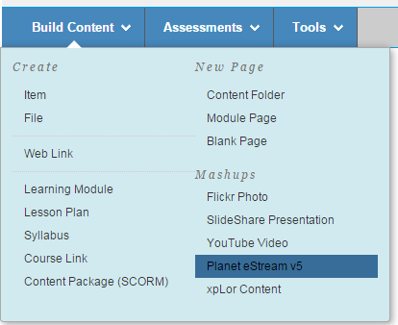
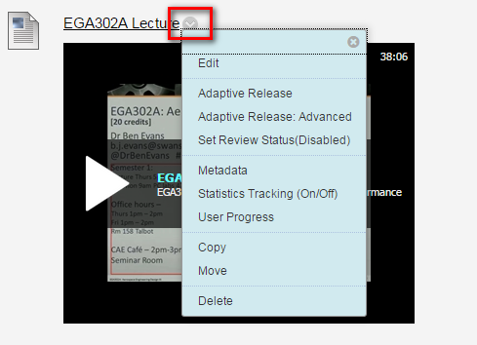
3. Ensure Edit mode is On

4. Click Build Content > Planet eStream v5

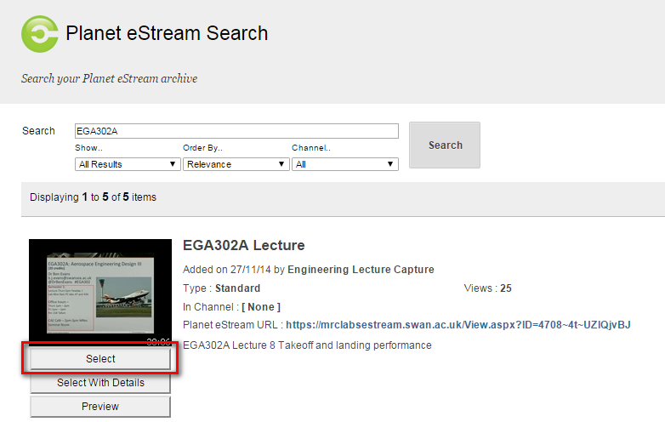
5. Enter the title you gave the recording for example module code and date of lecture: EG101_111015 and click Search
6. The recording should be shown below the search options, click Select

7. The recording has now been added to the Module content area
8. Use the additional drop down option to make any configuration changes such as Adaptive Release

How to create a new Content Area for Lecture Recordings

1. Ensure Edit Mode is On
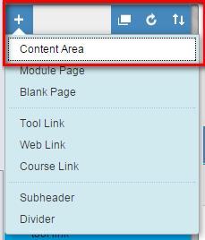
2. Click the Add icon at the top of the menu and select Content Area

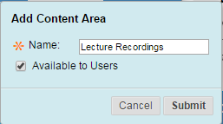
3. Provide a suitable meaningful name for the new content area
4. Select Available to Users then finally click Submit

Your new content Area has been added to the menu for the module, you can drag the content area label to move it up the menu list if you wish.

Canllaw i ddarparu recordiad o'ch darlith drwy Blackboard

1. Agorwch y modiwl yn Blackboard lle hoffech i'r ddarlith fod ar gael
2. Ewch i'r Ardal Gynnwys berthnasol. Argymhellir eich bod yn creu ardal gynnwys benodol ar gyfer y recordiadau (darllenwch y nodiadau ychwanegol ar ddiwedd y ddogfen hon am gyngor pellach)
3. Sicrhewch fod y nodwedd golygu ymlaen

4. Cliciwch Build Content > Planet eStream v5

5. Rhowch deitl i'r recordiad. Er enghraifft, côd y modiwl a dyddiad y ddarlith. EG101_111015 a chliciwch Search
6. Dylech allu gweld y recordiad islaw'r opsiynau chwilio. Cliciwch Select

7. Mae'r recordiad bellach wedi'i ychwanegu at ardal gynnwys y modiwl.
8. Defnyddiwch y ddewislen ychwanegol i wneud unrhyw newidiadau ffurfweddu megis Adaptive Release

Sut i greu Ardal Gynnwys Newydd ar gyfer Recordiadau Darlithoedd

1. Sicrhewch fod y nodwedd golygu ymlaen
2. Cliciwch yr eicon Add ar frig y ddewislen a dewiswch Content Area

3. Rhowch enw ystyrlon addas i'r ardal gynnwys newydd
4. Dewiswch Available to Users ac, yn olaf, cliciwch Submit

Mae eich ardal gynnwys newydd wedi'i hychwanegu at ddewislen y modiwl. Gallwch lusgo label yr ardal gynnwys a'i symud i fyny rhestr y ddewislen os dymunwch.

