How to download a copy of your lecture recording
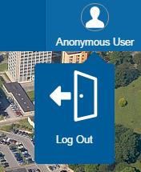
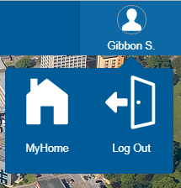
1. Navigate to https://videostream.swan.ac.uk
2. Hover over the Anonymous User icon and click Log Out
3. Log in using your University credentials
4. Hover over your username and click MyHome

5. On the MyHome page click the search icon
6. This will then display all of the recordings you have made

7. Once you have located the recording you wish to download click on the Show options Icon
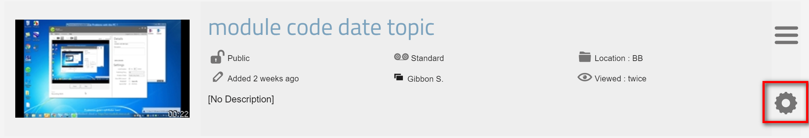
8. Click the Download icon on the options window
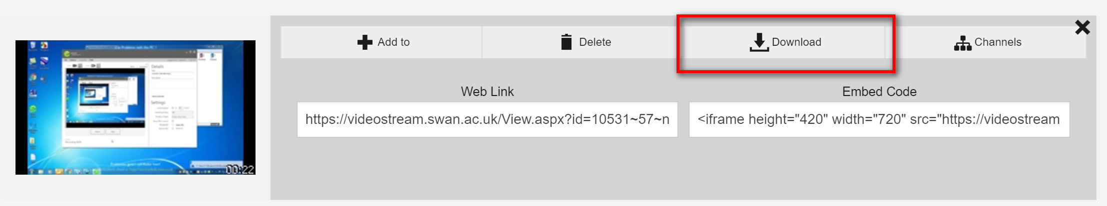
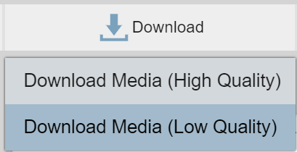
9. Choose the desired download Quality and the recording will be downloaded to you PC

Sut i lawrlwytho copi o recordiad eich darlith
1. Ewch i https://videostream.swan.ac.uk
2. Symudwch y cyrchwr i'r eicon Anonymous User a chliciwch Log Out
3. Mewngofnodwch gan ddefnyddio'ch manylion yn y Brifysgol
4. Symudwch y cyrchwr i'ch enw defnyddiwr a chliciwch MyHome

5. Ar y dudalen MyHome cliciwch ar yr eicon search
6. Bydd hyn yn dangos rhestr o'r holl recordiadau rydych chi wedi'u gwneud

7. Pan welwch y recordiad yr hoffech ei lawrlwytho, cliciwch ar yr eicon Show options
8. Cliciwch yr eicon Download yn y ffenestr opsiynau
9. Dewiswch ansawdd lawrlwytho a chaiff y recordiad ei lawrlwytho i'ch cyfrifiadur

