How to upload a video to eStream/Videostream
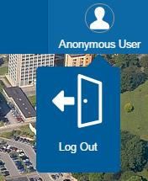
1. Navigate to https://videostream.swan.ac.uk
2. Hover over the Anonymous User icon and click Log Out
3. Log in using your University credentials
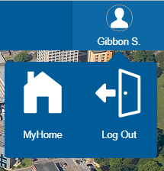
4. Click on the Create Icon located in the menu bar
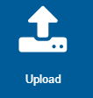
5. Then select Upload
6. Drag and drop the video file on to the page or click the link to locate the file on your PC
7. Perform the following:
- Uncheck Use filename for title
- Enter a Title
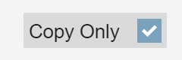
- Select a Publishing Policy; typically BB or your College Folder
- Only if the video is an MP4 file select Copy Only
8. Click Confirm
9. On the next screen click Start Upload
10. The file will then upload to the server and will be processed. Once completed the video will be available.
11. To view your uploaded video Hover over your name in the top right hand corner of the screen and click My Home

12. On the MyHome page click the Media icon then the search icon
13. This will then display all of the recordings/videos you have made/uploaded. The latest upload will be located at the top of the list.

Sut i lanlwytho fideo i eStream/Videostream
1. Ewch i https://videostream.swan.ac.uk
2. Symudwch y cyrchwr i'r eicon Anonymous User a chliciwch Log Out
3. Mewngofnodwch gan ddefnyddio'ch manylion yn y Brifysgol
4. Cliciwch ar yr eicon Create ar far y cwymplenni
5. Yna dewiswch Upload
6. Llusgwch y ffeil fideo i'r dudalen neu cliciwch y ddolen i ddod o hyd i'r ffeil ar eich cyfrifiadur
7. Gwnewch y canlynol:
- Dad-diciwch Use filename for title
- Teipiwch Deitl
- Dewiswch Bolisi Cyhoeddi; fel rheol, Blackboard neu Ffolder eich Coleg
- Dim ond os yw'r fideo ar ffurf ffeil MP4, dewiswch Copy Only
8. Cliciwch Confirm
9. Ar y sgrîn nesaf, cliciwch Start Upload
10. Yna bydd y ffeil yn lanlwytho i'r gweinydd a chaiff ei phrosesu. Pan fydd y broses hon wedi'i chwblhau, bydd y fideo ar gael.
11. I weld y fideo wedi'i lanlwytho, symudwch y cyrchwr i'ch enw yng nghornel dde uchaf y sgrîn a chliciwch My Home

12. Ar y dudalen MyHome cliciwch ar yr eicon Media ac yna'r eicon Search
13. Bydd hyn yn dangos rhestr o'r holl recordiadau/fideos rydych wedi'u gwneud/lanlwytho. Bydd y fideo diweddaraf a gafodd ei lanlwytho i'w weld ar ben y rhestr.

