Viewing all of your recordings and changing recording details
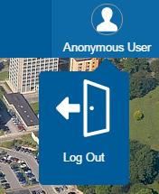
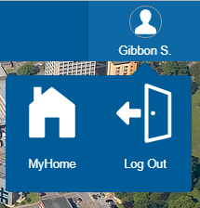
Viewing your recordings
1. Navigate to https://videostream.swan.ac.uk
2. Hover over the Anonymous User icon and click Log Out
3. Log in using your University credentials
4. Hover over your username and click MyHome

5. On the MyHome page click the search icon
6. This will then display all of the recordings you have made with additional information including:
- availability (public or private)
- location (server folder)
- creation date
- number of times viewed

Changing your recording details
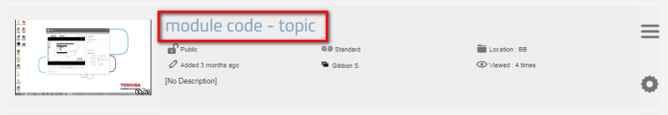
1. Once you have located the recording
which needs to be changed (steps 1-6
above) click the Recording title
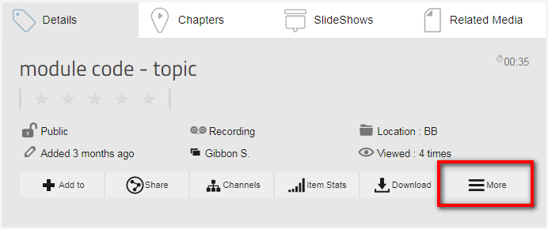
2. The recording will open and start playing. Scroll down to
see the recording Details information box, hover over the
More icon
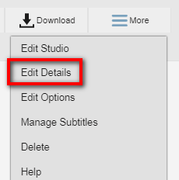
3. From the drop down menu select Edit Details
4. The recording details will appear below and any necessary changes can be
made

5. Click Save to make the change. It may take a while for the changes to take
effect on the server, please wait a few minutes for the page to update.

All normal lecture recordings should have the publishing policy/location of BB. If you need to change this, for example to keep an external presenters recording after the end of the Academic Year, in most instances choose your College from the available options.

Gweld eich holl recordiadau a newid manylion recordiad
Gweld eich recordiadau
1. Ewch i https://videostream.swan.ac.uk
2. Symudwch y cyrchwr i'r eicon Anonymous User a chliciwch Log Out
3. Mewngofnodwch gan ddefnyddio'ch manylion yn y Brifysgol
4. Symudwch y cyrchwr i username a chliciwch MyHome

5. Ar y dudalen MyHome, cliciwch yr eicon Search
6. Bydd hyn yn dangos yr holl recordiadau rydych wedi'u gwneud ynghyd â gwybodaeth ychwanegol, gan gynnwys:
- i bwy maent nhw ar gael (cyhoeddus neu breifat)
- lleoliad (ffolder ar y gweinydd)
- dyddiad creu
- sawl gwaith y cawsant eu gwylio

Newid manylion recordiad
1. Ar ôl i chi ddod o hyd i'r recordiad
yr hoffech ei newid (camau 1-6 uchod)
cliciwch Recording title
2. Bydd y recordiad yn agor ac yn dechrau chwarae.
Sgroliwch i lawr i weld y blwch manylion recordiad,
symudwch y cyrchwr i'r eicon More

3. O'r gwymplen, dewiswch Edit Details
4. Bydd manylion y recordiad i'w gweld islaw a gallwch wneud unrhyw
newidiadau angenrheidiol

5. Cliciwch Save i wneud y newid. Gall gymryd tipyn o amser i'r newidiadau
gael eu gwneud ar y gweinydd. Arhoswch ychydig funudau i'r dudalen gael ei diweddaru.

Dylai pob recordiad darlith arferol gael ei gyhoeddi ar Blackboard. Os oes angen newid hyn, er enghraifft, i gadw recordiad gan gyflwynydd allanol ar ôl diwedd y flwyddyn academaidd, yn y rhan fwyaf o achosion, dylech ddewis eich Coleg o'r opsiynau sydd ar gael.

