[](https://guides.turnitin.com/)

e-rater® Grammar Check Technology

**ETS e-rater is the spelling and grammar checking part of the Turnitin Feedback Studio.**

It is presented as a separate overlay in the new Feedback Studio layout. This can be switched on and off as you mark.

* Availability is either enabled or not (switched on/off) as an option in the initial assessment set up (below).
* If the service is enabled, automated comments highlighting spelling or grammatical errors will be put on to the script, but can be hidden from the marker’s view as required.

**ETS Settings are in the Turnitin assignment set up page.**

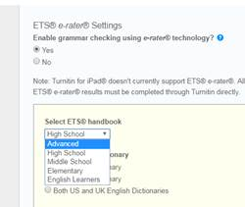

Options hidden in the dropdown menu in the web form suggest which level of education you are working in

On/off switch,

Select to use ETS e-Rater or not.

**Within the ETS set up you can:**

* Select the level of education at which your class is working (from the drop down menu).
* Select whether spellings are to come from English dictionary, US English dictionary, or both.
* Limited filter function can affect what appears by using the options (Listed) in the ETS section at the end of the Assignment set up page (see Image below).
* Comments can be set as on or off for :

1. Spelling
2. Grammar
3. Usage
4. Mechanics
5. Style.

**Further ETS Set up Options**

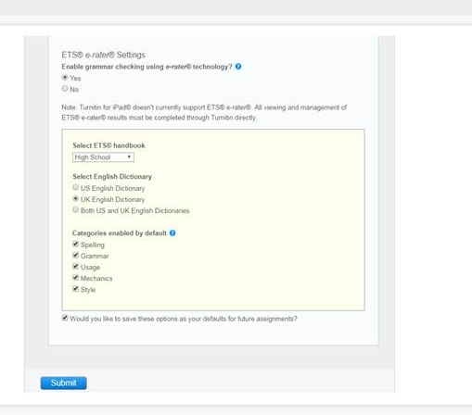

Drop down, as expanded above

Choice of English and/or American English dictionary

Various aspects of linguistics to include in the check (on/off options for each).

Remember to click on **Submit**, or new settings will not take effect.

Do you want to use ETS e-Rater tool? … ON/OFF

Remember to click on Submit or new settings will not take effect.Various aspects of linguistics to include in the check (on/off options for each).When the ETS e-Rater is set to be on, downloaded copies of scripts will include its comments as below:-

**ETS e-Rater as appears on Feedback Studio marking page.**

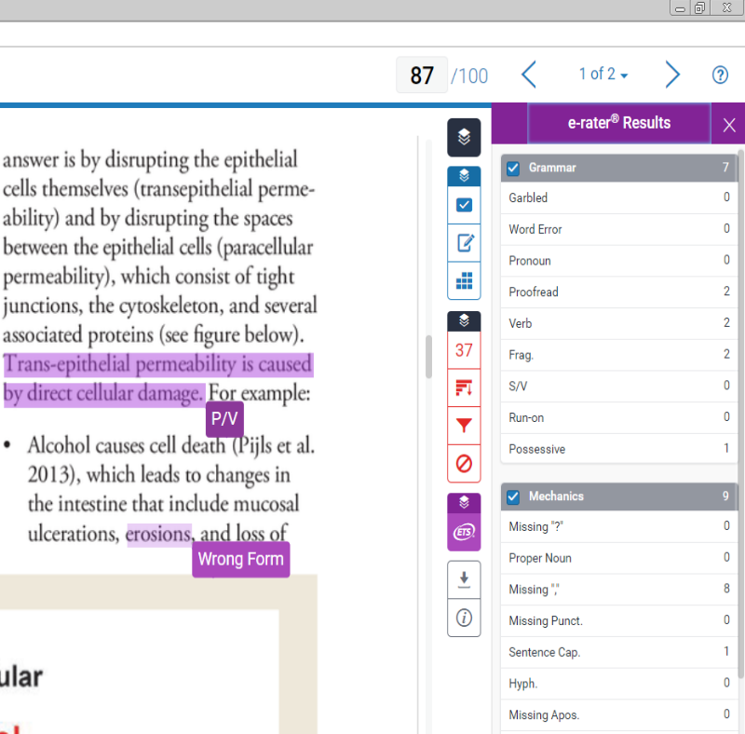

Note: Using the tick boxes within the grammar tools side panel, you can control which aspect of the checker are noted in your view of the script.

Purple ETS button opens ETS Grammar Tools side panel. Icon at top of button closes it again.

Clicking on a box expands it to show the full comment.

ETS comments are colour coded Purple.

Click Button to list active layers. Tick boxes allow you to show or hide each “Layer”

Collapse side panel.   
(all functions)