 

**Turnitin Feedback Studio**

**A click by click userguide**

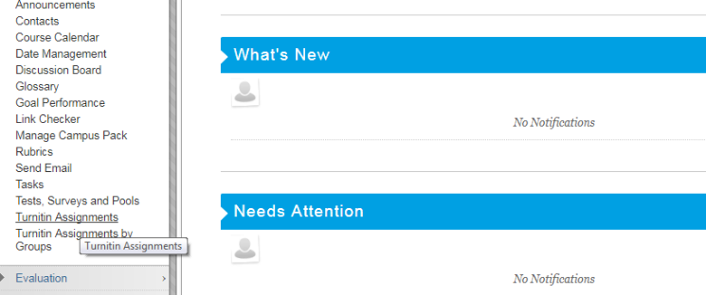

1: From the module homepage, select “Course Tools”  
and then "Turnitin Assignments"

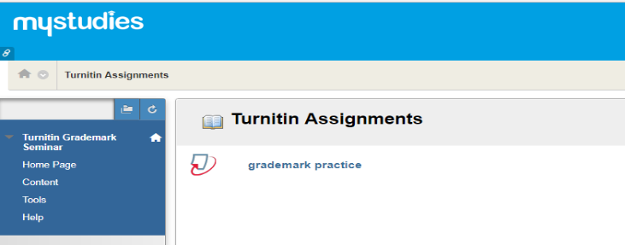

2: Select the assignment you are marking from the list.

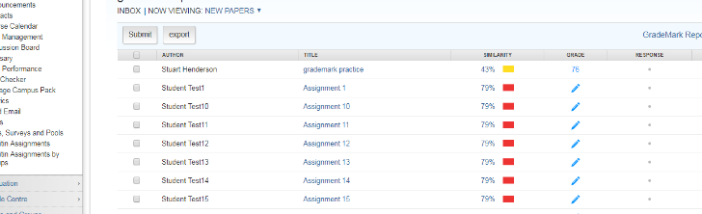

3: Select a script to mark by clicking on its title from the inbox.



4: Feedback Studio page will open showing the script (main Pane), and all the marking and originality checking tools (Right hand side bar) on the same screen. The small tab on the left of the screen opens a thumbnail view allowing quick navigation of the paper.

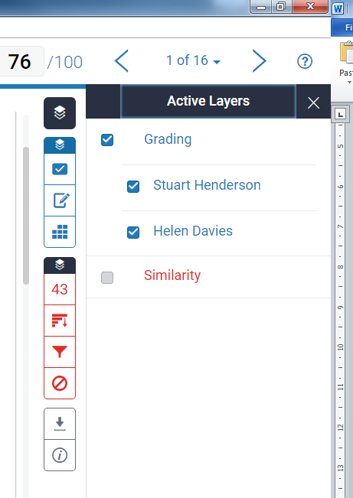

The Blue section gives access to the Marking Tools: Quickmarks (your saved comment bank);  
 Summary comment box, Voice recorder and ;  
Rubrics.

Markers comments can be overlaid. Tick boxes allow you to show layers of markers. Deselecting a box removes that marker’s comments from the script, allowing for double blind marking.

5. Main function buttons.

Red Section allows you to switch Originality report on/off, and gives access to Originality settings.

“Layers Buttons”. Use the Layers buttons to select which functions are in use and how much information is displayed in the Tool bar

Mark. Simply click in the box and type in the mark.

Arrows move you between scripts without returning to the inbox.

Use the download option to download a file or print hard copy of an assignment.

Marking

Use the Speech bubble icon to open a blank comment box (new icons in this box referred to in next step)

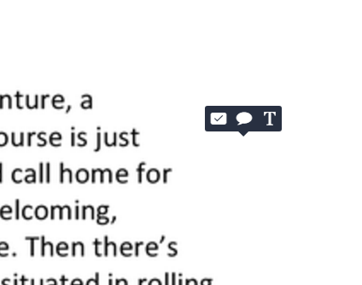

Click the tick box icon to access your Quickmark comments. All previously saved comments will still be available in Feedback Studio.

The “T” Icon allows you just to directly input text on the submission pane.

6. To comment on the script, click on the page where you wish the comment to appear. An option box will pop up.

**B,** *I* and U are used in the same way that they are in Word or other standardised packages. ie they allow you emphasise by changing the font in the comment to **Bold**, *Italic*, or to be underlined.

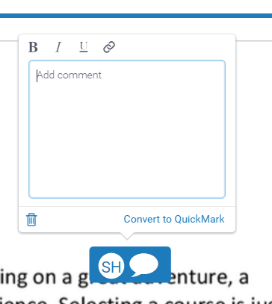

A typed comment can be saved to the comment bank using the Convert to Quick mark button, or use the cog icon on the main QM pane to access the manage tool.

The Chain Icon allows you to insert a hyperlink into the comment to illustrate your remark with an online resource. Click on the chain and just paste the link for text to which you wish to refer into the pop up box.

7. Note the new Icons in the top of  
 the comment box

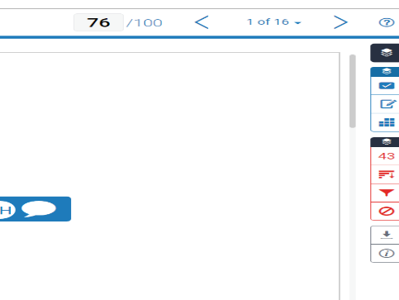

Arrows allow you to navigate between the different scripts without returning to the inbox.

The download options for marked or unmarked papers are accessed through the arrow button here.

You can manually enter a grade in the grade box by clicking in the box and typing the number.

8. Scoring and Navigation

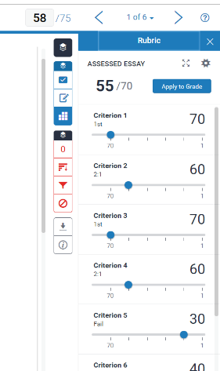

Click the expanding arrows if you need to see the complete grid with the written statements of attainment and scales included. This will open in a new window (See Example below).

Clicking the keypad Icon switches the right hand panel to show the Rubric sliding scales. Change the position of the blue dot on the slide to indicate the level of attainment you feel the assignment has achieved for each of the criteria from the rubric grid.

9. Rubrics

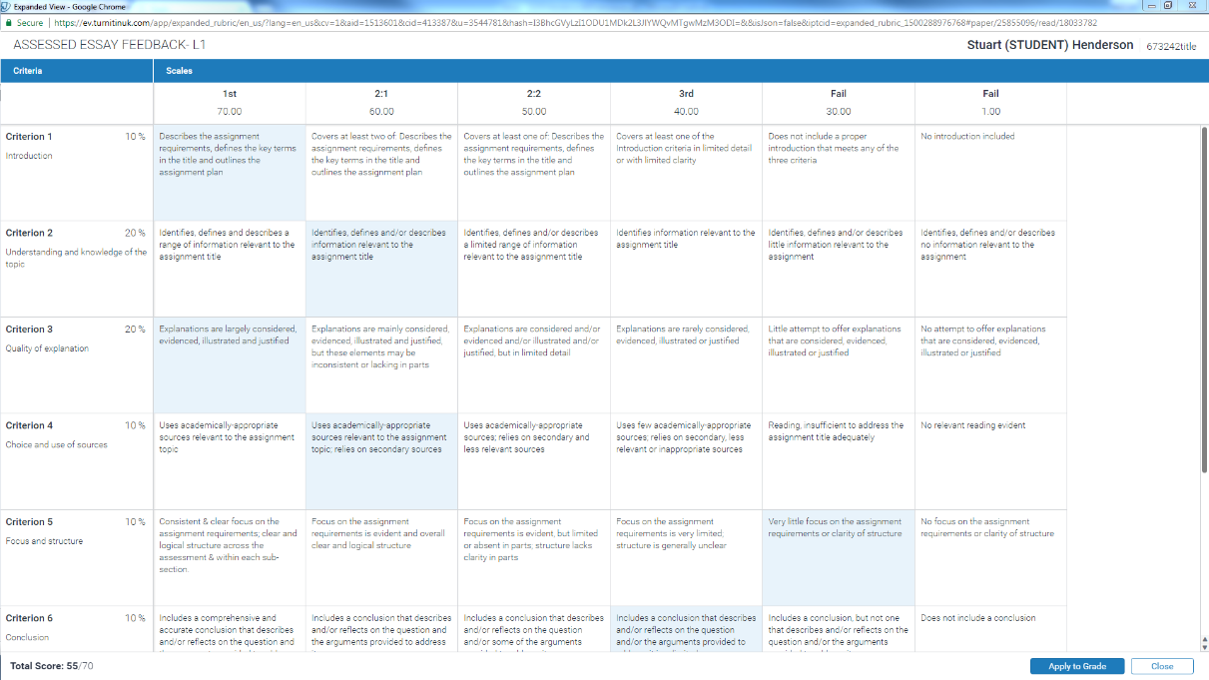

10. Highlight the level of attainment for each criterion by clicking in the relevant cell.  
If using the Rubric to calculate a grade, click the Apply to grade button and the grade box will be populated for you. This can be edited later.