ABC Facilitators Guide

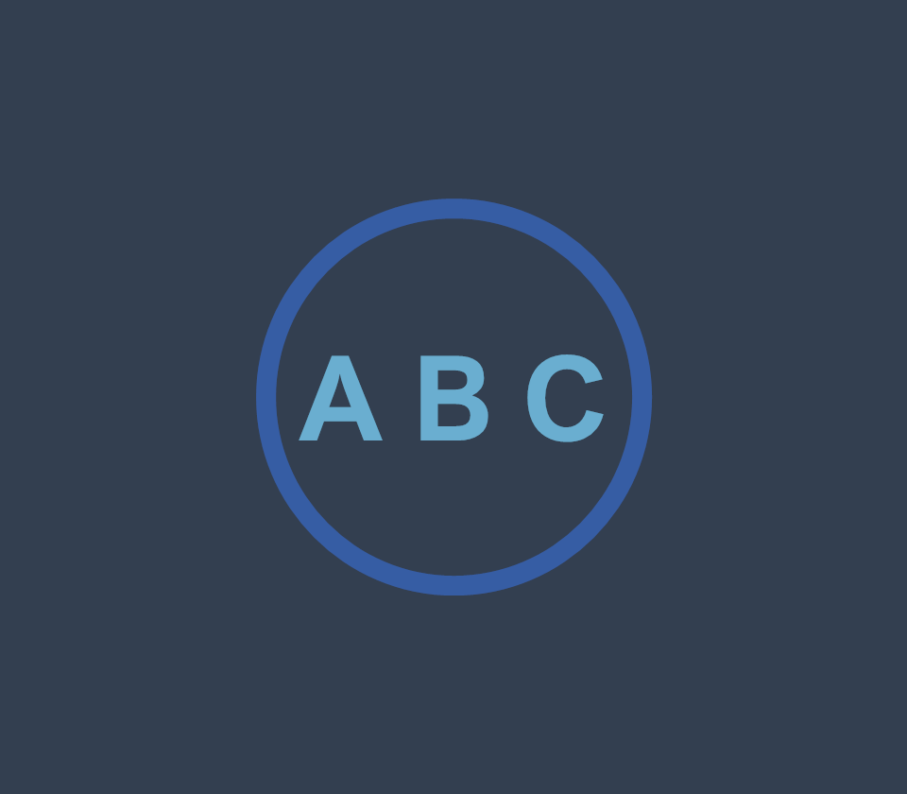

Resources available from https://salt.swan.ac.uk/abc

# About this guide

The guide outlines how to facilitate the ABC Learning Design workshop for module, course or programme review or development.

Each session has two elements: pre-workshop individual orientation tasks and a 90-minute group-based workshop.

It is crucial to emphasise the importance of completing the orientation tasks as they will ensure that the workshops are more productive.

# Workshop types

There are three ways the ABC workshops can be facilitated for modules: Review, development and review and development.

## Review

The goal of this type of workshop is to review an existing module. The outcome is descriptive, making the module structure visible and therefore easier to develop. This type of workshop is useful for teams who wish to perform an audit of their modules.

## Development

The goal of this type of workshop is to produce a visual representation of what an existing or new module should look like. This type of workshop is useful for teams who are familiar with their existing module and would like to change its structure to better represent new learning and teaching paradigms and strategic objectives.

## Review and Development

The goal of this type of workshop is to map an existing module and develop it to better represent new learning and teaching paradigms and strategic objectives. This type of workshop is useful for teams who are familiar with ABC methodology and have already given some consideration to the changes they wish to make to an existing module.

# Who should attend ABC LD workshops?

Anyone planning to design or review their module, course or programme for learning. Workshop participants can be lecturers, students, researchers and professionals without teaching experience. The workshop can be facilitated for modules or short courses.

# Who should be in the learning design team?

Teams seem to work best with 2 - 4 people per module. All of them should be teaching on a module, including the module lead.

If there is only one person teaching on a module it is recommended that they invite a colleague to join them as a “critical friend” team member. Collaboration and discussion with a colleague are valuable aspects of the workshop. If a colleague is unavailable, please contact SALT to see if an ABC facilitator is available.

It is important that the person who identified the need for the workshop agrees with module teams on most important elements that should be demonstrated in the design (an overview of intentions).

## Optional Team Members

If there is an educational technologist or instructional designer in the faculty, they should also be invited to the workshop.

Students (previous or current), academic developers

Module or programme lead

# At what stage of course/programme development should the workshop be facilitated?

The workshop can be facilitated for modules at any stage of the course life cycle: pre-approval, after the validation, or as a review of an existing module. It is important to discuss the development stage with participants prior to the workshop, so that the workshop can be tailored to focus on their needs. E.g. strategic dimensions, institutional strategy, change in learning outcomes or requirements from professional bodies, employability, etc.

# Where should the workshops take place?

Workshop facilitators should work with teams in their local setting (department/institute). The department should book a suitable room (see room set up below). The access to the room should be provided at least 30 minutes prior to the start of a workshop, so that the facilitators can prepare the room before participants’ arrival.

# Who can facilitate ABC workshop?

Because the ABC methodology is simple, effective and intuitive, anyone, with some preparation, can facilitate an ABC workshop. SALT is providing several orientation sessions suitable for those who wish to facilitate ABC workshops.

ABC workshops should not be facilitated by less than 2 facilitators (except for a small group of participants). If a co-facilitator is unavailable, please contact SALT see if an ABC facilitator is available.

The key focus of facilitators should be to introduce each activity clearly and concisely and to make sure the groups keep to the timings. By circulating around the tables, facilitators can steer groups in the right direction, answer pertinent questions and keep participants to the schedule.

# For how many people can workshop be facilitated?

There is no ideal number of participants per workshop. It is important that they can all see and hear the facilitators’ presentation and that there is enough space for facilitators to walk around the working teams. If you are facilitating a workshop for more than 6 teams (tables), it is advisable to invite more than two facilitators, in order to pay the required attention to all participants. This provides better “at table” support and ensures the smooth progress of the workshop.

# Pre-workshop individual orientation tasks

The pre-workshop orientation tasks and workshop information should be sent to participants at least a week in advance. Participants should familiarise themselves with the concepts and terminology prior to the workshop. It is important to inform participants not to worry about references to the Arena Blended Connected or the Connected Curriculum as these are UCL specific concepts.

## Tasks

Participants should review the key requirements and descriptors of their patch / course / programme and have these available during the workshop.

Participants should be asked to:

* Watch “ABC Curriculum Design” [<https://www.youtube.com/watch?v=3C1gTHApg8A>]
* Watch Professor Diana Laurillard’s “Introduction to the 6 learning types” [<https://www.youtube.com/watch?v=wnERkQBqSGM>]
* Read the descriptions from the Learning Types cards and consider how they represent some of their learning activities

# Workshop Room Set Up

The room should be set up before participants’ arrival (it usually takes 20 - 30 minutes to set up the tables for 6 - 8 teams).

A PC or laptop and projector are required for the ABC presentation.

Tables should be arranged for group work. Each surface should be able to accommodate the A1 storyboard and provide enough space for participants to sit comfortably and for facilitators to move around the tables and interact with the participants during the workshop.

If refreshments for the teams are provided, it is advisable to keep them in a separate area of the workshop room.

You can use our workshop checklist to make sure you have all the resources required for workshop.

Don’t forget to allot some time in your room booking for tidying up!

## Table setup

It is strongly recommended that resources are kept tidy, and to have the same order of cards and other resources on each of the tables. Each set of resources is arranged around an A1 storyboard sheet.

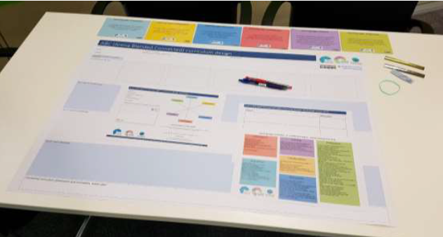

Figure 1: Table set up

Nataša Perović of UCL describes the table set up at [https://www.youtube.com/watch?v=N9WprkRrOx0](https://www.youtube.com/watch?v=N9WprkRrOx0&feature=youtu.be)

### Printed Materials

Digital copies of these materials are available from <https://salt.swan.ac.uk/abc>

Please see our “Printing Information” guide for printing advice.

|  |  |
| --- | --- |
| ABC A1 Storyboard | A1 Storyboard  1 per module |
| ABC A1 Learning Types Card | A6 Learning Types Card  6 of each card per module, 36 cards in total |

|  |  |
| --- | --- |
| ABC A4 Module Information Sheet | A4 Module Information Sheet  1 per module |
| ABC A4 Additional Activities Sheet | A4 Additional Activities Sheet  1 per module |
| ABC A4 Action Plan Sheet | A4 Action Plan Sheet  1 per module |

### Additional Materials

* Red Pen
* Blue Pen
* 10 Silver Stars
* 10 Gold Stars
* 8 – 10cm2 Blu Tack
* Elastic Band
* Ruler

## Activities

Timings for each of the workshop activities can be found below. Each activity should be introduced and described before participants begin.

This video by Clive Young and Nataša Perović of UCL demonstrates each part of the process <https://www.youtube.com/watch?v=vBWpcqBl4ek> and includes images of several different completed storyboards for reference.

### Workshop Activities

|  |  |  |
| --- | --- | --- |
| Activity | Instructions | Timing |
| Session Outline and Workshop Introduction | Objectives  Think, pair, share  A simple description of the ABC methodology and workshop specific expectations or goals | 10 minutes (facilitators) |
| Activity 1A | Complete the basic information and module summary section of the Module Information Sheet | 5 minutes |
| Activity 1B | Share module title and details | 5 minutes |
| Activity 2A | Select Learning Types Cards and arrange them in sequences on the timeline on the A1 Storyboard to map the students’ journey | 20 minutes |
| Activity 2B | Learning Types Cards are turned over and learning activities are selected from or added to the cards | 20 minutes |
| Activity 2C | Assessment activities are highlighted, and the storyboard is agreed as a representation | 10 minutes |
| Activity 3 | Add the module learning types and blend to the Module Information Sheet | 5 minutes |
| Activity 4 | Complete the Action Plan sheet | 10 minutes |
| Plenary | Discuss points of integration  Collect feedback  Final questions | 5 minutes |