Turnitin Feedback Studio:
To Set-up a Turnitin Assignment

How do I Set an assignment up in Feedback Studio?
Note: In some colleges, all the setting up Turnitin Assignments is taken care of by your academic admin offices. It is still worth noting what options may be available to you as it will to enable you to request any variance from the admin default that you deem appropriate for the work you are setting.
Turnitin assignments are set up via a webpage accessed through Blackboard.
Before creating a Turnitin assignment, check what your local College policy is, as some colleges have opted to perform this function centrally through their admin offices, whilst others leave this to the academics running the course.
- The set up page is accessed through the Assignments tab in the left hand menu bar (As the naming of the menu items can be locally set, your college or another contributing colleague may have changed this button to read Assessment and Feedback, or Turnitin, or similar, but default is Assignments).

- Hover over the Assessments tab at the top of the page, producing a set of dropdown options.
Ignore the Assignment option, as this sets up a Blackboard assignment, rather, opt for the Turnitin UK Assignment towards the foot of the list. Clicking this will land you on the beginning of the assignment set up page.

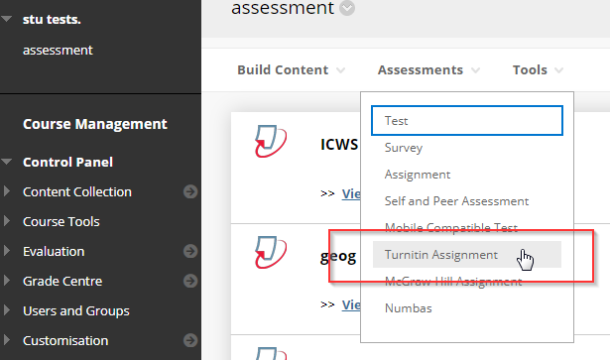

- The standard option for a single submission essay assignment would be “paper assignment”. You can click on the radio buttons to check what the other options do, but basically, Peermark allows you to divide submissions amongst the cohort for the students to review the papers of their peers, and the Revision option allows for multiple submissions without overwriting those that went before.
- Click on “Next Step” to move on.

- On the new page you will have to set a title for the assignment.

- The “Point Value” field is optional. It can be left blank, or given a nominal value for the amount of points available for the assessment. Do not give it a value of “0”. This can give the system the impression that there are no points available which can cause issues later in the feedback process.

- NB: If you want all the submissions to be checked for Originality (Plagiarism) you will need to click on the first radio button marked “Allow only file types that Turnitin can check for originality”.
Turnitin will currently accept the following file types to generate Originality Reports:
- Microsoft Word® (.doc / .docx)*
- OpenOffice Text (.odt)**
- Google Docs via Google Drive™
- WordPerfect® (.wpd)
- PostScript (.ps/.eps)
- Adobe® PDF (but not image based PDf’s; Ie scans of text)
- Microsoft PowerPoint® (.pptx, .ppt, .ppsx, and .pps)***
- Microsoft Excel® (.xls and .xlsx)****
- HTML
- Rich text format (.rtf)
- Plain text (.txt)
- Hangul Word Processor file (.hwp)
However, if your assignment does not need to be run through the checker you can select the option for “Allow Any File Type”. This will allow you to mark anything, even with no physical submission, so for example, were you to be marking a physical entity that the student had made, a student presentation, or performance/presentation where there was no actual paper to mark, Grademark will generate a marking sheet for population with comments.
Any submission presented in an accepted file type would still be run through the checker.

- There are three dates and times to be set (see below);
Start Date: This is when the assignment and associated materials would become available for the students to see on Blackboard.
Due Date: By when the students must have submitted to Turnitin. Assuming the assignment is set as Paper Assignment (i.e. not to expect drafts and resubmissions) there is nothing to stop the students submitting early. This being the case the marker is at liberty to start marking, thus extending their (usually 3 week) marking period.
It is suggested that the time for the due date is set within office hours. This is so that last minute students who may have difficulties with their submission can talk to their tutor or college before they are deemed Out of Time.
Post Date: this is the date by which the markers should have completed their marking, as feedback is released to students at this point.
The post date is editable, but only remains so until the time set. Once the feedback has been released it is too late to recall it.
If you do need to change the post-date you should ensure that all the students are notified of the change and the reasons for it to avoid too many complaints.

Title field
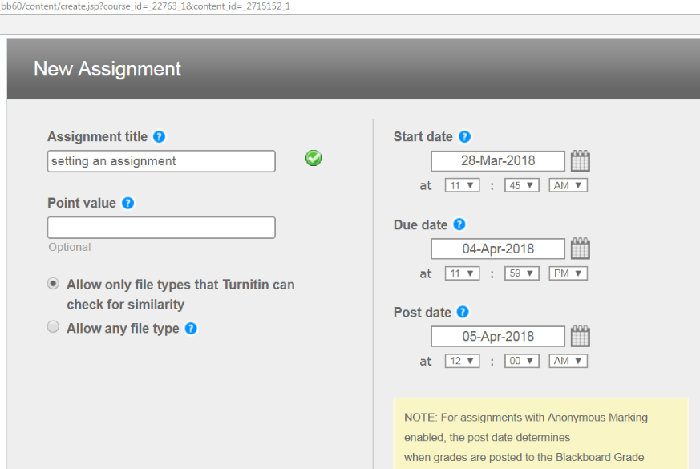
Three dates/times to populate.
Start Date
Due Date
Post Date (feedback available to students).

Optional Settings.
Scroll down the page until you see Optional settings, the page will then expand giving a range of options, most of which are with regards to the amount of detail to be included in originality reports and whether these are to be released to students. Work through these options, marking your preferences using the radio buttons (ie. clicking dots in circles).

Similarity generation.
This setting governs at what point the system produces a similarity report, but also whether multiple submissions are possible or not.
In the first option only one submission can be made and the report is produced straight away.
In the second option a report will be produced upon submission, but further submissions will be accepted and will prompt a revised report.
On due date will allow students to resubmit drafts, but the report will not be generated until the due date. No further submissions will then be accepted
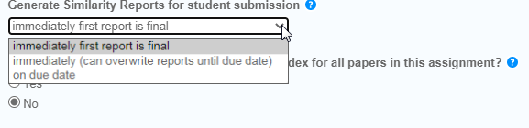
Reveal Grades to Students Only on Post Date?
This option would usually want setting to “yes”. This should ensure that all feedback becomes available to the students at the post date, rather than as their papers are marked.
Enable Anonymous Marking?
The university has a policy in favour of the use of anonymous marking, so as default, the “yes” option ought to be selected.
NB: If you have specific reason to disable anonymity, be aware that this can allow Blackboard to pull the marks from the Feedback Studio and post them in the Gradecentre prior to the post date. The answer to this is to use the “Hide column to users” function in the Gradecentre to hide the column for that assignment, remembering to unhide it when you are ready for the feedback to be released.
Rubrics. The Rubric manager tool is found at the foot of these options. Instructions for this are to be found in a separate “Using Grademark Rubrics” Instructions page.
Marking functionality. Will also be laid out in a separate instruction leaflet

