ABC Learning Design

Virtual Workshop
https://salt.swan.ac.uk/abc-learning-design

ABC Learning Design Virtual Workshop by Matthew Alan, Darren Minister, Luke O’Sullivan and Suzannah Pugh. Swansea University, (2020). Resources available from https://salt.swan.ac.uk/abc-learning-design

Module Information
Module Name:
Module Code:
Module Convenor:
Module Lecturers:
Module Description:
(140 Characters)
Date:

Learning types

ACQUISITION

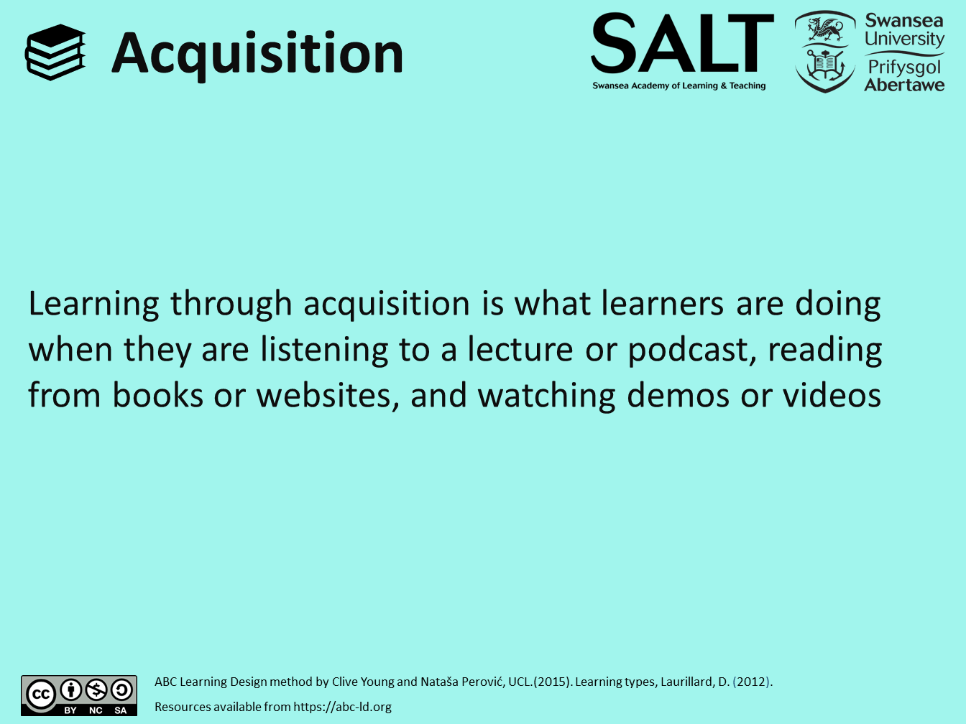
 | Conventional method  - reading books, papers  - listening to teacher presentations face-to-face, lectures  - watching demonstrations,  - master classes | Digital Technology  - reading multimedia, websites, digital documents, and resources  - listening to podcasts, webcasts  - online forum where the teacher answers questions  - field / lab observations (media / blog / wiki)  - MCQs with automatic formative feedback

DISCUSSION

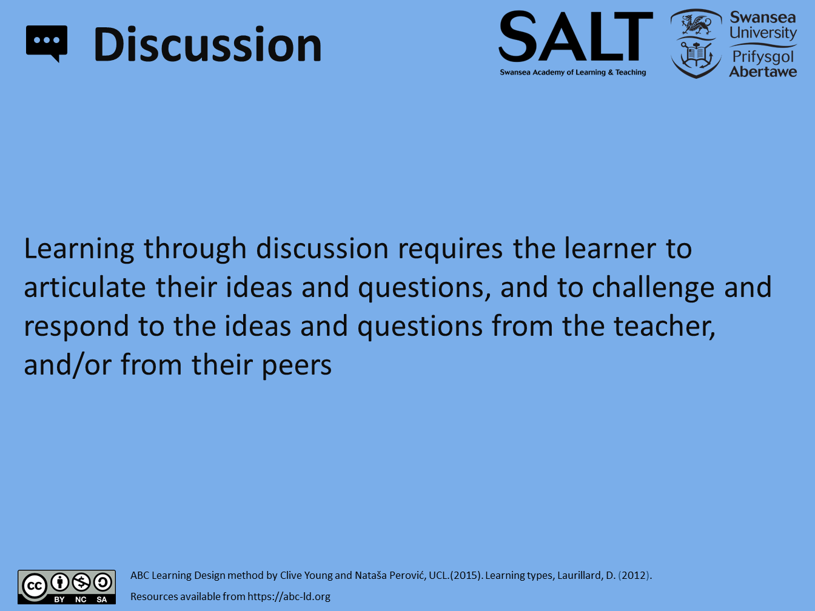
 | Conventional method  - tutorials  - seminars  - discussion groups  - class discussions  - group discussion on topic, problem,  - reading or artefact  - interview an expert | Digital Technology  - online tutorials  - webinars  - email discussions  - discussion forums  - social networking

COLLABORATION

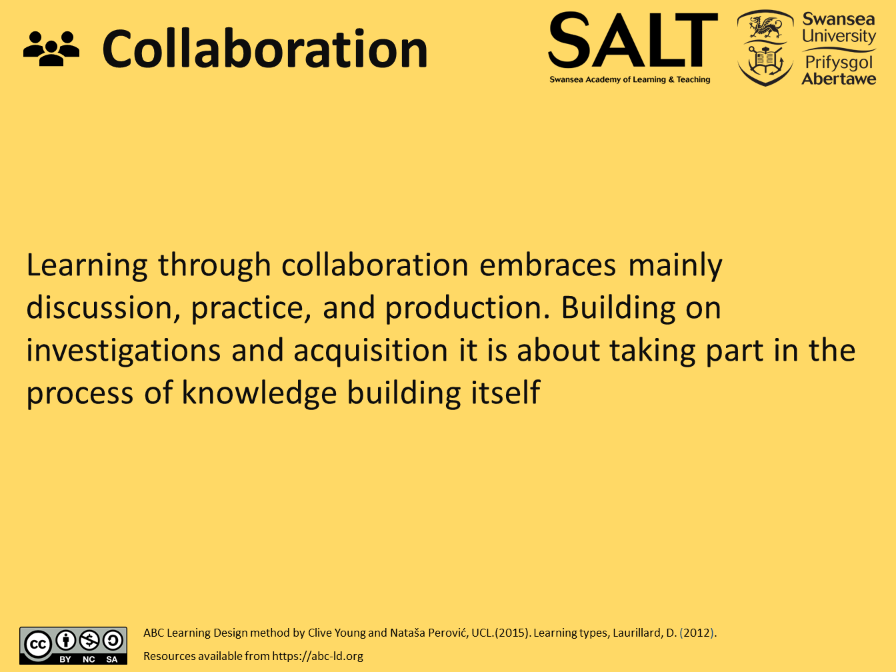
 | Conventional method  - small group project  - discussing others’ outputs  - building joint output  - peer mentoring | Digital Technology  - small group projects using online forums, wikis, chat rooms, etc, for discussing others’ outputs  - collaborative wiki / database / glossary  - social networking participation  - collaborative digital media production

INVESTIGATION

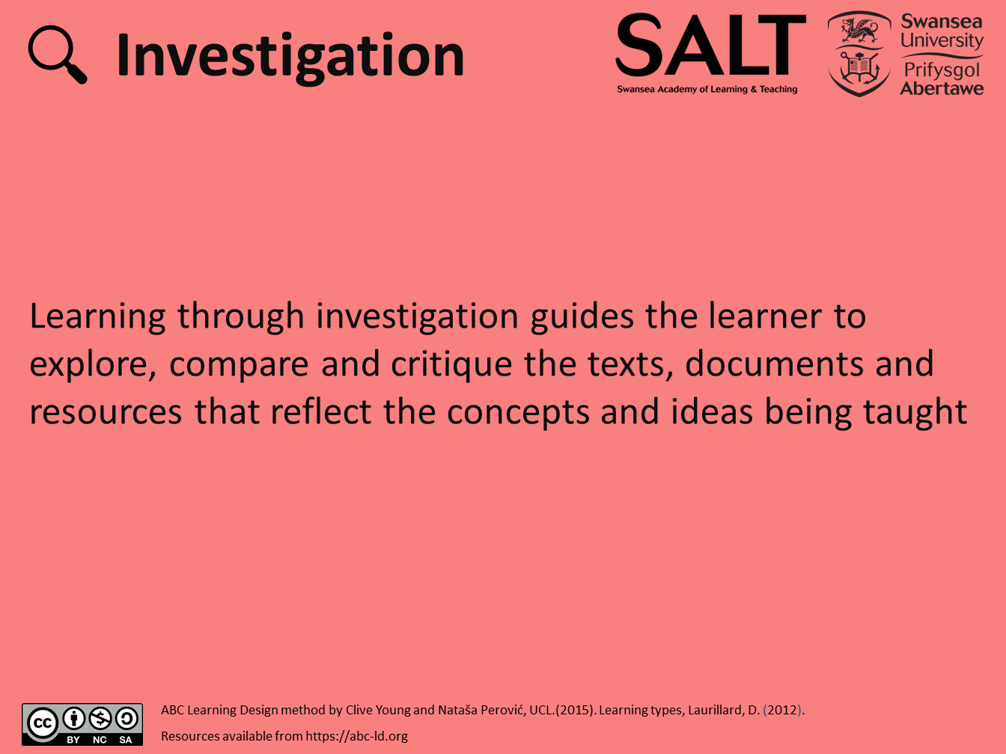
 | Conventional method  - using text-based study guides  - analysing the ideas and information in a range of materials and resources  - using conventional methods to collect and analyse data  - comparing texts  - searching and evaluation information and idea | Digital Technology  - using online advice and guidance  - analysing the ideas and information in a range of digital resources  - using digital tools to collect and analyse data  - comparing digital texts  - using digital tools for searching and evaluating information and ideas

PRACTICE

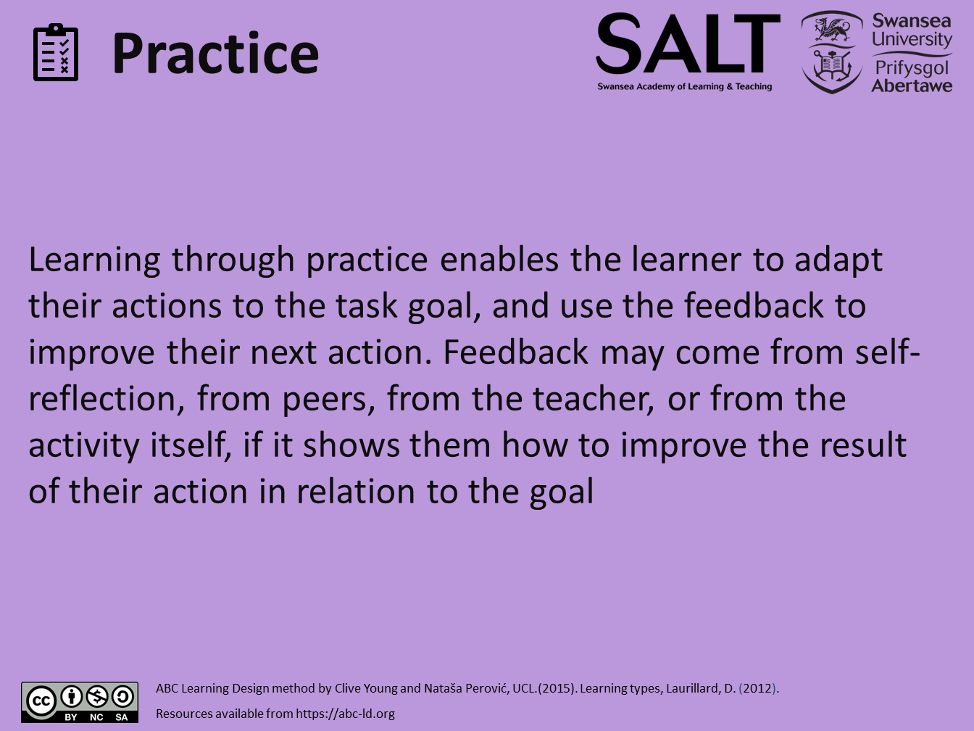
 | Conventional method  - practising exercises  - doing practice-based projects  - labs  - field trips  - face-to-face role-play activities | Digital Technology  - using models  - simulations  - virtual labs and field trips  - online role-play activities  - quizzes  - reflective blog / forum

PRODUCTION

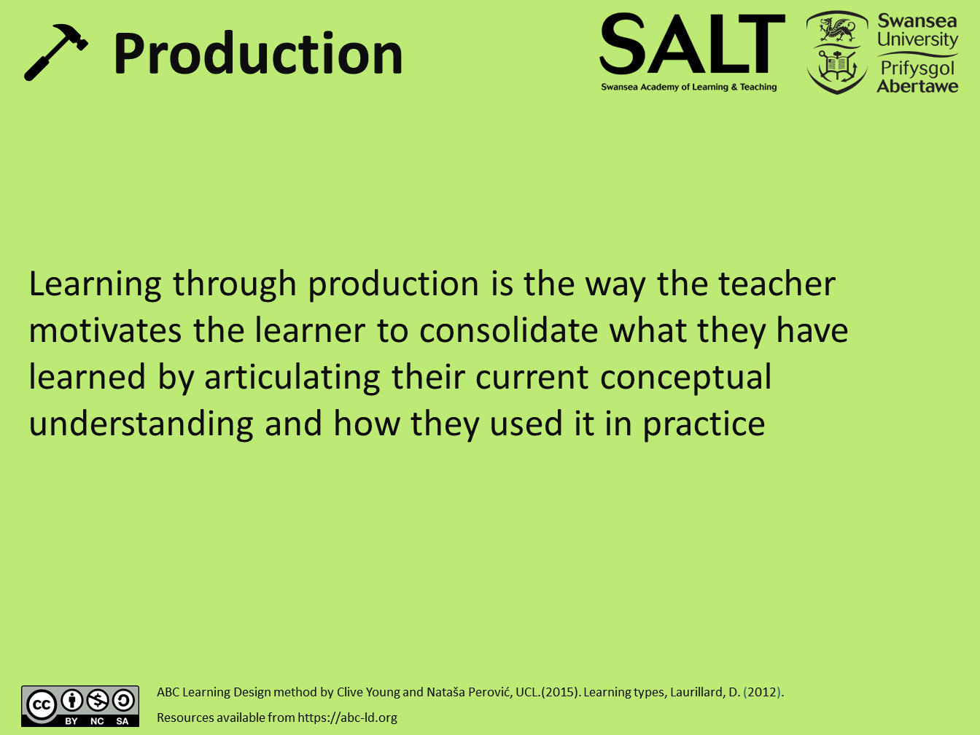
 | Conventional method  - statements  - essays  - reports  - accounts  - designs  - performance  - artefacts  - animations  - models  - videos  - case studies | Digital Technology  - producing and storing digital documents  - representation of designs  - performances  - artefacts  - animations  - models  - slideshows  - photos  - videos  - blogs  - e-portfolios  - websites

Storyboard

[Edit Name]

Learning Types |  | Storyboard
Assessment |  | Notes | Notes | Notes

Action Plan

Follow-up tasks
Task | Owner | Due

Templates

Week or Topic Name Template

Learning Types |  | Storyboard
Assessment |  | Notes | Notes | Notes

Example

Week 1: The making of the Middle Ages

Learning Types |  | Storyboard
 |  | - reading multimedia, websites, digital documents, and resources  - listening to podcasts, webcasts  - collaborative glossary | - online tutorial  - quizzes  - comparing digital texts | - Turnitin Assignment
Assessment |  | Notes | Notes | Notes

