Canvas Course Access: College Administrative Staff.

In the Canvas Learning Platform, staff with appropriate administrative access can access any module within their section.
To perform most of the tasks that you complete in any course, there is no need to separately enrol as an instructor, as was the case in Blackboard.
In the Canvas set up there are different levels of admin access available.
Most admin staff will have access to the courses within their specific departments/area of responsibility, whilst Senior admin staff will be able to access any course within their college account.
If you think you do not have the correct level of access for your needs, a request will have to be made via nominal people in your college before this permission can be granted.
Once you have had admin access added to your account, these instructions will show you how to search for and access your courses.
The steps below show how to gain full access to any course within the remit of your admin account permissions, without the need for any further enrolment:

Accessing Your Admin Account
- Login to Canvas.
- Click on Admin in the navigation menu at the left side of screen. Once clicked the tab will change to white.
Only staff with an administrative role will have this tab on their menu bar.

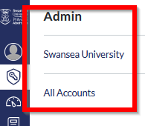
- In the pop out menu, click on the name of the account you are working in:
Account names may vary from those of your colleagues, depending upon your level of access.
Senior admin staff will see the accounts for the whole of their college, but there will be sub accounts of the College account for the different areas of the college.
Departmental admins may only have access to those courses within their specified areas.
Your account(s) will then be listed where “Swansea University” appears in the image.

Finding and Accessing Courses

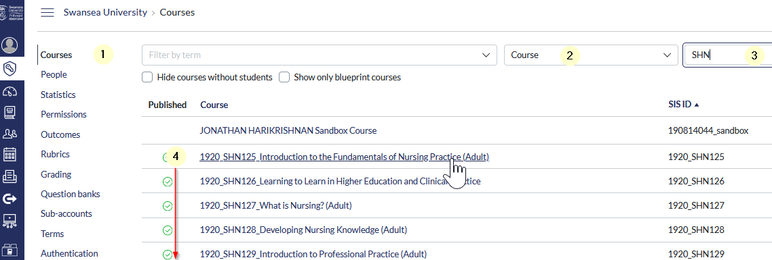
Click the admin tab in the navigation menu and then follow these steps (the numbers relate to the image above):

- Select the Courses tab in left hand menu
- Using the chevron arrow to see the list, ensure that the middle of the top boxes is set to Course.
- Type the course code into the right-hand box.
The search will display a single course if given an exact code, but will accept part of a code and list any course codes that include that sequence.
In the example above, typing a partial course code will…
- list all SHN courses by stopping at SHN
- In the generated list, click on the title of the Course you wish to work in.
This will take you directly into the course.
You can now perform your usual tasks, without having specifically enrolled on the course.

Turnitinuk.com: access to inboxes.

As an external third-party tool, Turnitinuk access to submissions is an exception to this rule.
The above process alone may not add the course to your list of Canvas courses within Turnitinuk.com. However, you should not need to go so far as to enrol as instructor in all the Canvas courses you administer just in order to achieve this. Merely interacting with Turnitin via the course should force the update of the class list with your access permissions …

Access the course via the admin role, as described above.

Click through into Turnitin using an assessment link from within the course.
This action will flag your activity within the Turnitin system, and add the course to the Canvas courses in the list you see when you login to their website interface.
- Verify your course list in Turnitinuk.com has been updated by logging into the website and checking your access list. If you were already logged in at this point, you may need to refresh your screen to see the changes implemented.
- Do remember to ensure you are looking at the correct course list.
The list you may have, headed Swansea University, will show all your previous Blackboard courses, but does not include your more recent Canvas courses. These will be separately listed in a list marked Canvas.

