## *Turnitin Functionality Unavailable through the Canvas Integration* There are a number of Turnitin functions which were previously available to us through the Blackboard integration, but which do not appear in the Canvas-Turnitin deployment. We have found that by accessing Turnitin via the Turnitinuk.com website, we can still complete most of these tasks.

We have not needed this route previously, as we could access everything required through our Blackboard integration.   
Where possible, Canvas should still be used as our route to Turnitin, but instructions for accessing functions where it is not are laid out below.  
The list may not be exhaustive, and instructions will be added if we discover any further instances in which the website route would be needed.   
  
The initial login instructions are common for each of these functions, with specific directions for each function listed below subsequently described.

***NB: Please make sure the site you are logging in at is Turnitinuk.com, and not Turnitin.com.  
The two pages look identical, making it easy to miss this error and wonder why your credentials are failing to give you access.***

*Missing Functionality Available through TurnitinUK*

Access to Submissions made through Legacy Blackboard modules.  
Submissions on behalf of a student.  
E-mailing late/non submitters.  
E-mail all students.  
Adding students to a class in Turnitin (Roster sync):  
 Individually  
 Upload a class list

## *Accessing the Site*

1. Go to [https://www.turnitinuk.com/login_page.asp](https://eur03.safelinks.protection.outlook.com/?url=https%3A%2F%2Fwww.turnitinuk.com%2Flogin_page.asp&data=02%7C01%7CS.D.R.Henderson%40Swansea.ac.uk%7Cfa403993db614379399f08d7cce92738%7Cbbcab52e9fbe43d6a2f39f66c43df268%7C0%7C0%7C637203174070056178&sdata=AbHHa%2FmNQMkiBctkjhC5XddNnL3c%2FNKhSBPMIH275vM%3D&reserved=0)
2. Enter the entirety of your Swansea e-mail address.

As previous Swansea users, you will already have an account set up, but the first time you access the website, you won’t have a password set up yet.

1. Click the “***forgot password, click here***” option, ***not*** “new user”.
2. Set up new password following the Turnitin instructions.
3. 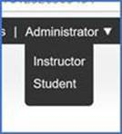[Login](https://www.turnitinuk.com/login_page.asp) using your new password.
4. Inside Turnitin, select the “***Instructor***” option from the role dropdown at the top of the page.

You will see a list of the modules in which you have used Turnitin.  
If you are looking for Canvas courses, they will be listed separately from Blackboard modules, as in the image below.  
list of Blackboard and Canvas modules in which you have used Turnitin.


* Click on the Title of the course/module you want to work in. Only the blue writing is responsive.
* 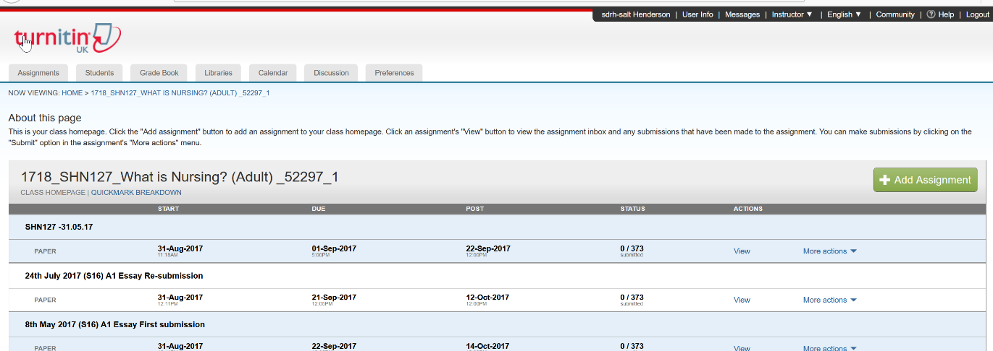Here you return to a standard Tii interface more akin to that you were used to, but with a different set of tabs. You will see a list of assignments which have been set in the selected module.

## *Accessing Legacy Submissions*:

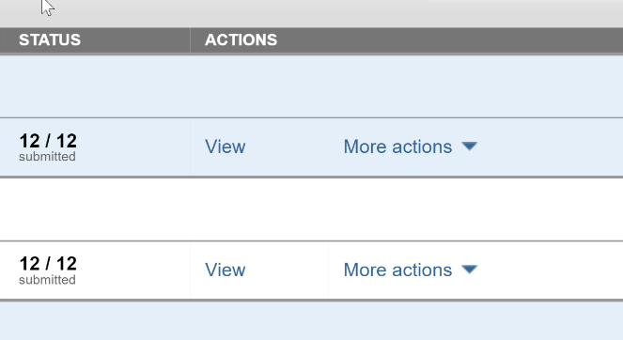

* Find and click “**view**” in the correct assignment to open the inbox view
* Find the name of the student whose work you wish to access

’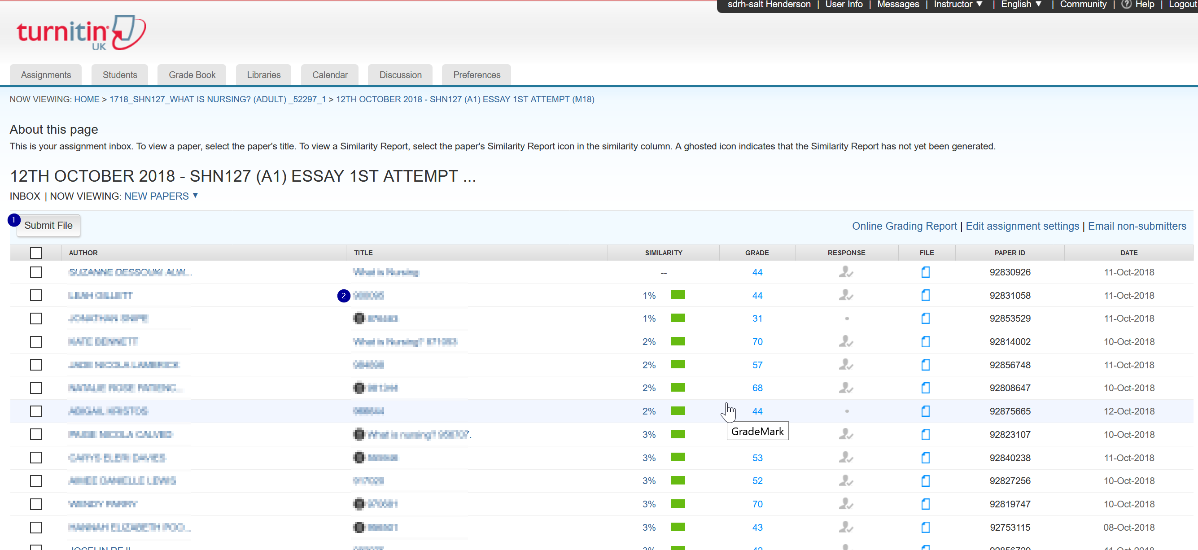

* To view the paper with its feedback and or Similarity report, click on the submission’s title.
* 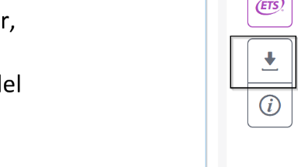The document viewer will open, showing the script. There will be a “**read** **only**” warning, telling you it will not be possible to edit the file.
* Towards the foot of the right-hand tool bar is a download button. Click the button and select the “**Current View**” option.
* The paper will be downloaded to your computer, from where you could save or print it.

## *To Submit on Behalf of a Student:*

* Follow the accessing the site instructions to access TurnitinUK and use your course list to find the course where you wish to submit the students work.
* 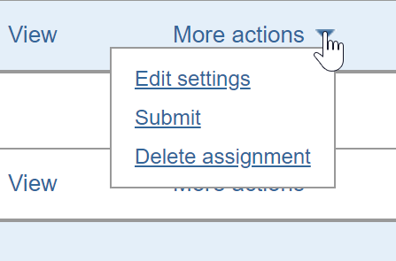In the assignment list, find the assignment you wish to work in.
* Click on more actions and select submit.

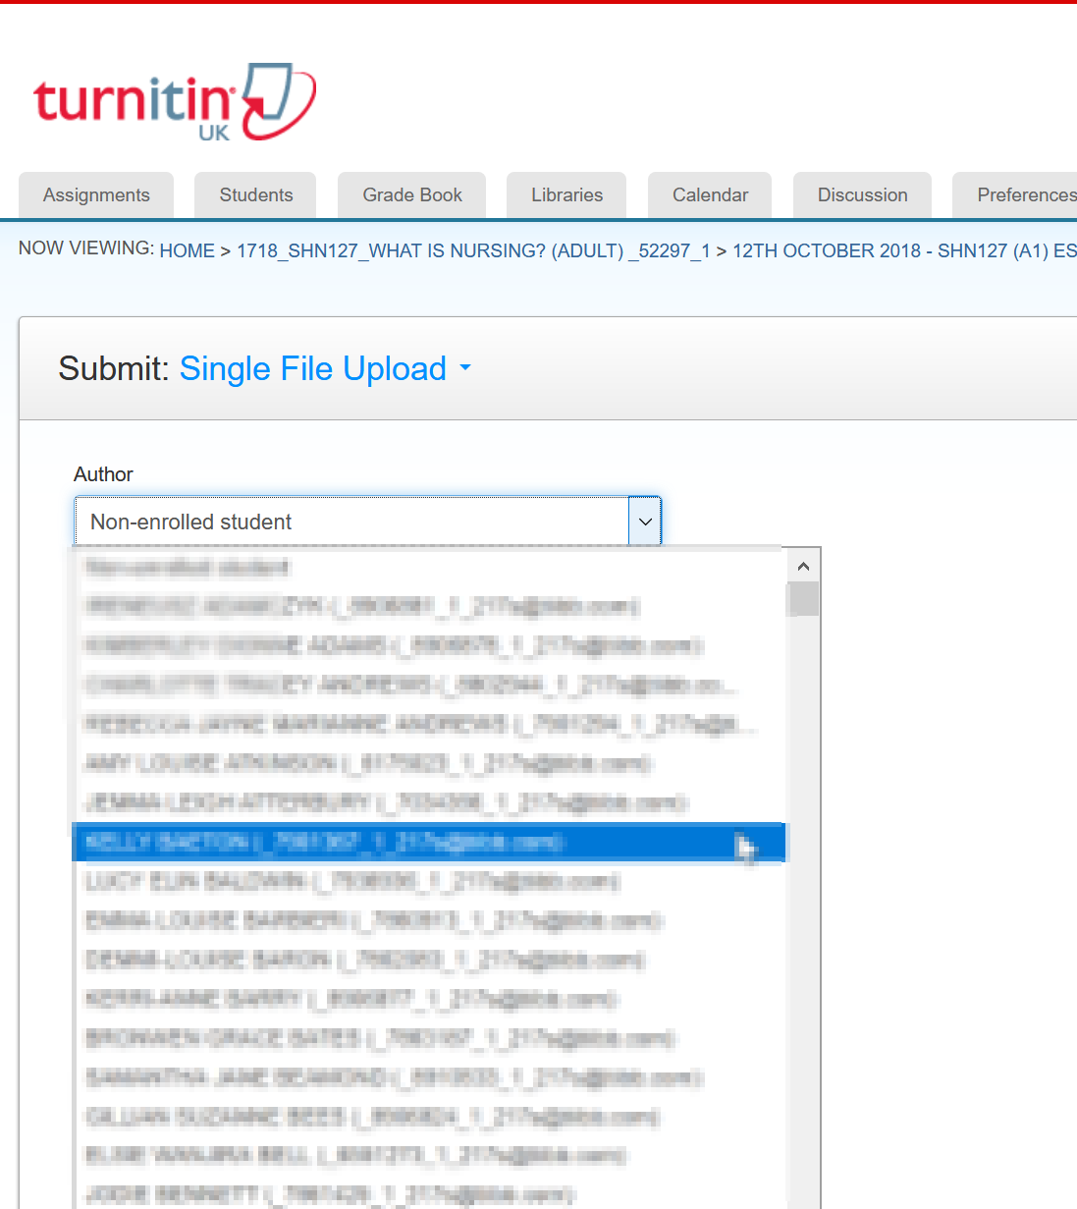

* On the new page, click on the dropdown arrow to show names of students enrolled on the course.
* Click on the name of the student for whom you wish to submit. The name boxes will populate for you.
* Fill in the submission title, then browse for the file and upload it to the system
* Please do keep a record of Submission Number/receipts and forward these to the student. They appear as an onscreen confirmation page upon successful submission. A simple screenshot is a quick effective to save this evidence.

## Canvas Enrolments not Appearing in Turnitin Class lists/inbox View.

In the Blackboard/Turnitin integration, there was a function button marked **Roster Sync.**This button sent a query from Turnitin to Blackboard requesting a current module enrolment list, updating the inbox with the names of late enrollers, or missing students.  
There is no equivalent function in the Canvas integration.

*Student self-enrolment:*   
If a student is enrolled in a Canvas module, but not yet listed in the Turnitin class list it presents no issue for submission, or in the subsequent marking/administration of their submission. The student would not even know they were not listed. They would still have access to the submission link through the Canvas course and simply by submitting through that link, they are automatically added to the class list on the Turnitin side.

## *Manual College additions*

Either enrolled teachers or college admin staff would be able to add students in a Turnitin class.  
Single students can be added through a very simple sign up form, or a class list can be uploaded to the system.

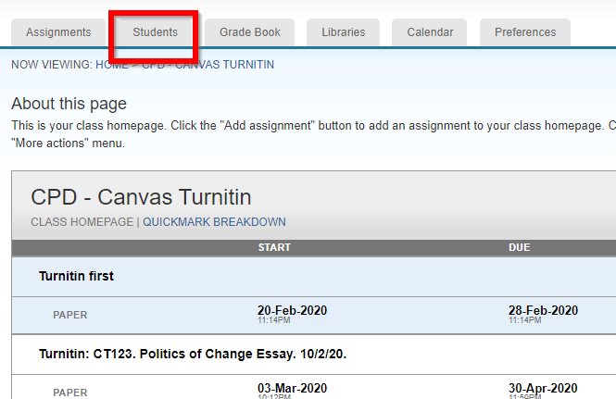For Single students  
Follow the accessing the site instructions to access TurnitinUK and use your course list to find the course you need to add the student to.

* Click on the Class name to access that course. You will land on the **class homepage** showing all assignments set in the course.
* From the tabs above that list, select **Students.**
* Above the list on the **Students page** select the **Add Student** option
* 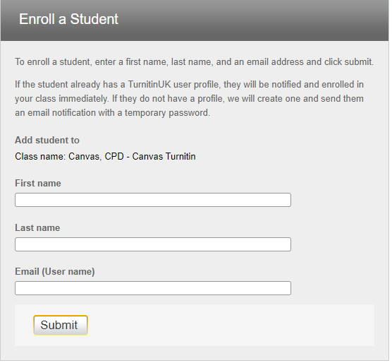In the pop-up box enter First name, Last name, and e-mail (Username) in

the appropriate fields, remembering to click **Submit**.

### To Upload a class list

Access the **Students page** as above in the Single student instructions.

* 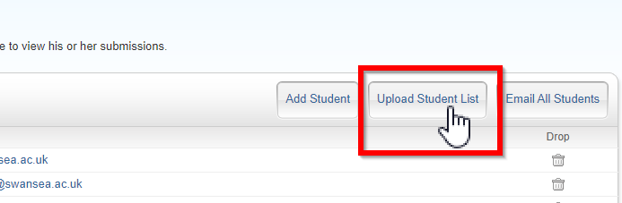Click on the **upload student list** tab

* 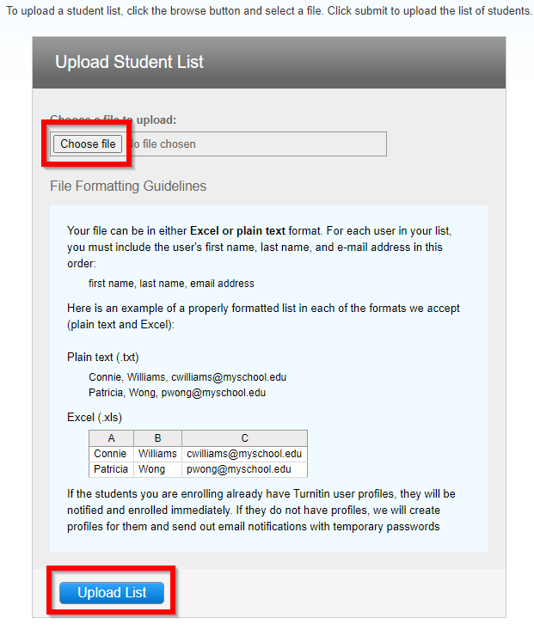Once you have a list saved to your PC, use the **Choose File** button to browse your file store to upload your class list.
* The file will need to be in either plain text format, or Excel, with **First name, last name, Email address.** They must be in this order and separated by commas in plain text format or as three separate columns in Excel.
* The **more info** button on the page expands the panel to tell you how to lay these out.
* Having selected the file click on Upload list.

## To E-mail non-submitters

* Follow the accessing the site instructions to access TurnitinUK and use your course list to find the course where the students you wish to contact need to submit their assignment.
* Check that you are in the Assignments tab at the top of the page.
* Find the assessment you want to work with in the list on your class homepage and click **View**.
* 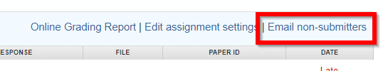There are three options on the right, in the top bar of the Inbox. Click on **e-mail non-submitters**.

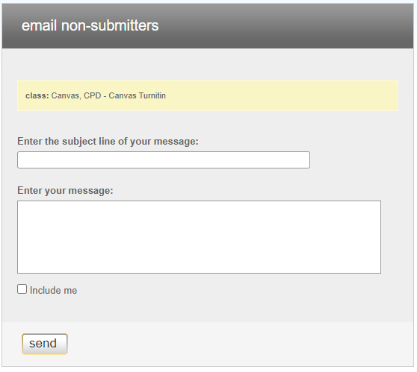

* Write a title for your message in the subject line field.
* Type what ever mesasage content you need to deliver in to the Message field.
* Tick the **Include me** box if you wish to receive a copy of your mailing.
* Remember to click Send to complete the task.
* Turnitin will mail all students who have not submitted using their @swansea.ac.uk address.

## To E-mail all students

From the Students tab in a Turnitin class you can e-mail all students in the class simultaneously.

* 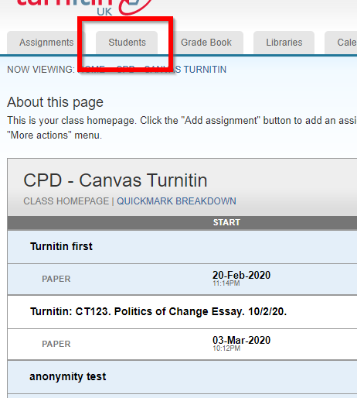Follow the accessing the site instructions to access TurnitinUK.
* Use your course list to find the course in which you need to contact the students.
* Click the course name to enter the course and select the **Students** tab at the top of the page.

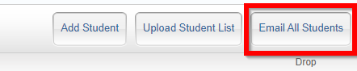

* Select the **Email All Students** from the tabs in the bar at the top of the student list.

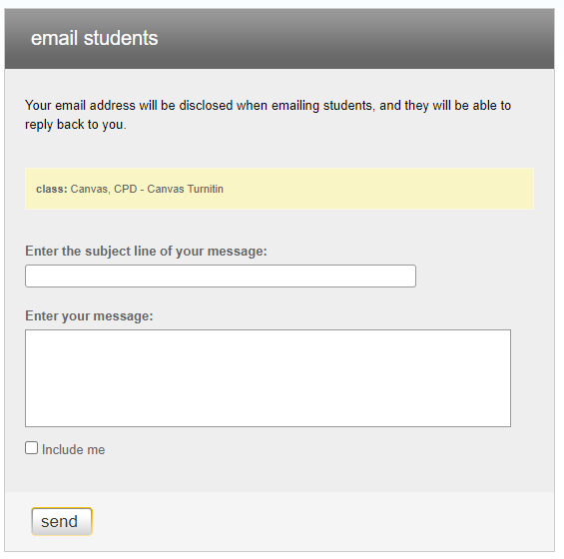

* Enter a title for your message in the **subject** field.
* Write your message to the students in the **Message** field.
* Tick the **Include Me** box to receive a copy of the message yourself.
* Click **Send** to send the mail.
* Turnitin will mail all the members of the class using their @Swansea.ac.uk E-mail address.