If a course expiry date has lapsed in Turnitin when there are still assessments to be run, the expiry date can be edited by accessing Turnitinuk.com. This will also reactivate an expired course
Instructions for accessing the site can be found here.
- Login to the site and select the Instructor option from the role drop down options at the top of the screen.
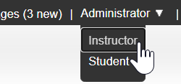
- Find the class you are looking to work with in your class list.
If you worked with Blackboard previously, you will find your Blackboard modules listed separately from Canvas, so make sure you are searching in the right list.
The Blackboard list will have the heading Swansea University. Your Canvas list will be listed as Canvas.
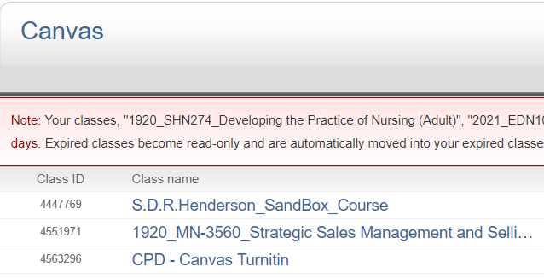
- Each course entry in the list has Cog Icon in the edit column. Click on the cog for your course.
- This will take you to an edit form.
- You will need to give the class a subject area, by selecting from the dropdown list (“other” is available if there is not one which seems to reasonably fit).
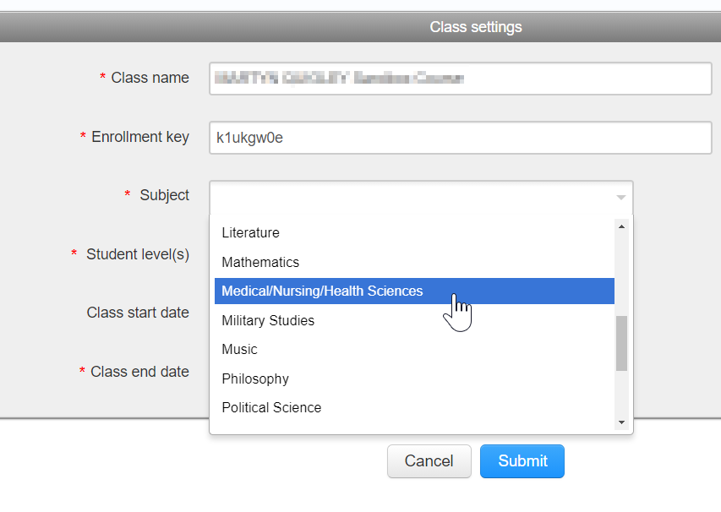
- You will need to select a level of study from the dropdown list.
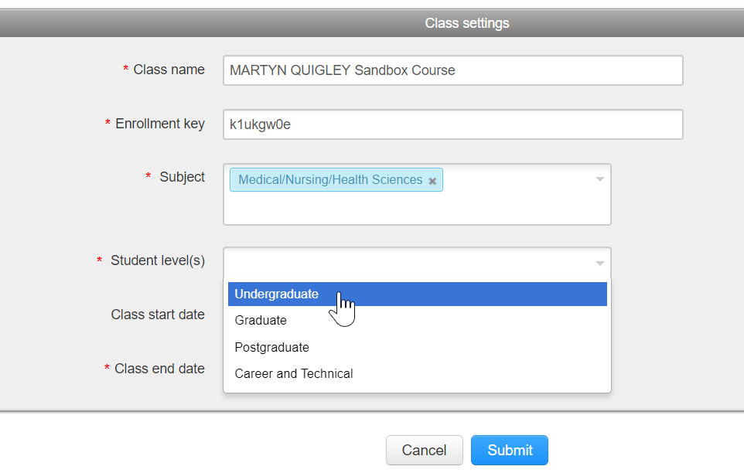
- Using the calendar icon to open up the calendar options, select the date you wish the class to expire.
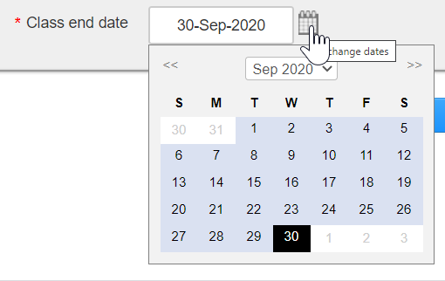
- Finally, remember to click the Blue Submit button at the foot of the page.
If you want to double check that your settings have held, return to the class list and the class should now have “Active” marked in the status column.

